**BARANGAY MONITORING AND MANAGEMENT SYSTEM  
WITH DATA ANALYTICS**

**A Project Study**

Presented to the Faculty of the  
**Electronics Engineering Technology Department**College of Industrial Technology  
Technological University of the Philippines  
Ayala Blvd., Manila

by

**JOHN PAUL C. ANDAL  
GENIKKA ROSE T. BAUTISTA  
ABEGAIL CATALAN  
LIONEL M. HERNANDEZ  
CHRISTIAN JAMES D. PUNZAL  
BJORN P. VILLARTA**

In Partial Fulfillment of the Requirements for the Degree  
**Bachelor of Engineering Technology major  
in Computer Engineering Technology**

**2023**

****Technological University of the Philippines

**COLLEGE OF INDUSTRIAL TECHNOLOGY**

Ayala Blvd., Ermita, Manila 1000

Telephone: (02)301-3001 loc. 201, Email Address: [cit@tup.edu.ph](mailto:cit@tup.edu.ph)

**APPROVAL SHEET**

The project study entitled “**BARANGAY MONITORING AND MANAGEMENT SYSTEM WITH DATA ANALYTICS**”, prepared and submitted by **JOHN PAUL C. ANDAL, GENIKKA ROSE T. BAUTISTA, ABEGAIL CATALAN, LIONEL M. HERNANDEZ, CHRISTIAN JAMES D. PUNZAL,** and **BJORN P. VILLARTA**, in partial fulfillment of the requirements for the degree **Bachelor of Engineering Technology major in Computer Engineering Technology**, is hereby approved and accepted.

**JOHNATHAN RICHARD A. BARRIOS**

Adviser

**GEMMA D. BELGA**

Chairman

**AIMEE G. ACOBA** **CHERRY D. CASUAT**

Member Member

**MARC ARDIE V. ARDIENTE**

Member

Approved in partial fulfillment of the requirements for the degree **Bachelor of Engineering Technology major in Computer Engineering Technology**.

**PROF. ELPIDIO S. VIRREY**

Dean, College of Industrial Technology

Date: ___________________________

**DEDICATION**

We humbly dedicate the completion of this research study to our Almighty God, who gave us knowledge, guidance and strength; it also dedicated to our beloved parents, who have been our source of inspiration and gave us hope as they continue supporting us; to our friends who shared their advice and encouragements to fulfill this study; to our professors that who share their learnings and skill with us; and lastly, to ourselves who give all of our effort to finish this study.

Praise to be God!

**ACKNOWLEDGEMENT**

This study was supported by residents and employees of Barangay 193 – Zone 20, Pasay City and CIT Professors. We thank from the bottom of our heart to Prof. Johnathan Richard Barrios and Prof. Aimee G. Acoba who aided and expertise on this study. We also thank our parents for the moral and financial support for this study and the Barangay 193 citizens and workers that participated on conducting this study. We want to thank the friends and classmates who become critique and reliable adviser for this study. Without all those people we cannot surpassed this part of our life and to Almighty God that always bless and guide us.

**ABSTRACT**

This study was conducted to make a Barangay Management Information System (BMIS) that easier to identify barangay needs that are important for planning nutrition and development, implementing projects, monitoring their progress, and evaluating. BMIS helps local government offices, and other field staff report information more effectively. It also makes it easier to assess the progress of implemented projects, which will be the basis for reprogramming and/or updating development plans. The study also aims to create a web application for Barangay 193, Pasay City and to develop a monitoring and management information system for the data of residents and other activities in the barangay using the web application. The web application was develop using Atom Software, HTML, CSS, PHP, JavaScript, MySQL and XAMPP. All the required features demonstrated functionality, reliability and accuracy based in testing defined in the test cases executed for two cycles in the test environment. Therefore, we conclude that our group successfully made a system that makes it simple for the user to access the information they require. The system can securely store and organize records. The system uses data analytics to calculate the data by categorizing it.

**TABLE OF CONTENTS**

**PRELIMINARIES Page**

Title Page i

Approval Sheet ii

Dedication iii

Acknowledgement iv

Abstract v

Table of Contents vi

List of Tables viii

List of Figures viii

Contents

Chapter 1 - INTRODUCTION 1

Background of the Study 1

Objectives of the Study 2

Scope and Limitations 3

Significance of the Study 4

Chapter 2 – CONCEPTUAL FRAMEWORK 6

Review of Related Literature and Studies 6

Conceptual Model of the Study 14

Operational Definition of Terms 15

Chapter 3 - METHODOLOGY 17

Project Design 17

Project Development 23

Operation and Testing Procedure 28

Evaluation Procedure 34

Chapter 4 – RESULTS AND DISCUSSION 35

Project Description 35

Project Structure 36

Project Test Results 49

Project Capabilities and Limitations 52

Project Evaluations Results 56

Chapter 5 - SUMMARY OF FINDINGS, CONCLUSIONS AND RECOMMENDATIONS 57

Summary of Findings 57

Conclusions 57

Recommendations 58

REFERENCES 60

APPENDICES 62

RESEARCHERS’ PROFILE 109

|  |  |  |
| --- | --- | --- |
| **LIST OF TABLES** | | |
| **Table** | **Title** | **Page** |
| 1 | Test Case Form | 28 |
| 2 | Over-all Summary of Functionality Test Cases | 30 |
| 3 | Test Execution Summary | 30 |
| 4 | Test Incidents Log | 31 |
| 5 | Error Priority Levels and Severe Classifications | 32 |
| 6 | Likert Scale in Evaluating the System | 33 |
|  |  |  |

|  |  |  |
| --- | --- | --- |
| **LIST OF FIGURES** | | |
| **Figure** | **Title** | **Page** |
| 1 | Web Page Management Information | 7 |
| 2 | Software Quality Evaluation | 12 |
| 3 | Conceptual Model of the Study | 14 |
| 4 | Context Diagram of the System | 17 |
| 5 | Data Flow Diagram Level 1 | 18 |
| 6 | Data Flow Diagram Level 2 | 19 |
| 7 | Entity Relationship Diagram | 19 |
| 8 | Use Case Diagram | 20 |
| 9 | System Architecture Diagram | 21 |
| 10 | Prototype Development Model | 22 |
| 11 | Site Map (Admin) | 25 |
| 12 | Site Map (Staff) | 26 |
| 13 | BMMS – Login Page (Admin) | 35 |
| 14 | BMMS – Dashboard Page (Admin) | 36 |
| 15 | BMMS – Activity in Dashboard Page (Admin) | 37 |
| 16 | BMMS – Residence Page (Admin) | 37 |
| 17 | BMMS – Add New Resident (Admin) | 38 |
| 18 | BMMS – Document Page (Admin) | 38 |
| 19 | BMMS – Sample Required Field for Documents (Admin) | 39 |
| 20 | BMMS – Barangay Income Report (Admin) | 40 |
| 21 | BMMS – Barangay Document Income (Admin) | 40 |
| 22 | BMMS – Barangay Income Page (Admin) | 41 |
| 23 | BMMS – Add Other Barangay Income (Admin) | 42 |
| 24 | BMMS – Barangay Profiles Page (Admin) | 42 |
| 25 | BMMS – Create New Official (Admin) | 43 |
| 26 | BMMS – Account Page (Admin) | 43 |
| 27 | BMMS – Create System User (Admin) | 44 |
| 28 | BMMS – Customize Page (Admin) | 44 |
| 29 | BMMS – Residence Page (Staff) | 45 |
| 30 | BMMS – Document Page (Staff) | 45 |
| 31 | BMMS – Required Fields for Documents (Staff) | 46 |
| 32 | BMMS - Kiosk Page (Residents) | 46 |
| 33 | BMMS – Set PIN Code in Kiosk (Residents) | 47 |
| 34 | BMMS – Enter Registered PIN Code in Kiosk (Residents) | 47 |
| 35 | BMMS – Display Information in Kiosk (Residents) | 48 |

# Chapter 1

# INTRODUCTION

This chapter includes background of the study, objectives of the study, scope and limitations of the study and significance of the study.

## **Background of the Study**

In this era of advanced operating technologies, everyone uses high technology to simplify tasks. Everyone is derived to new technologies and equipment as a result of technological advancement. Certain barangay, though, seem to be lagging behind in terms of catching up with modern advancements and this potential hasn't even been fully realized. Most barangays maintain important documents and files for the barangay as well as records of its residents using manual methods (inettutor.com, 2021). Barangay might not fully appreciate the advantages and limitations of modern computer technology. The majority of the barangay's workers used paper, but the barangay's population is growing daily. In the past, using paper was simple due to the lower population and simpler management of residents (Cañete, Fuellas, & Tina-an, n.d.).

Barangay 193 – Zone 20 is one of the oldest barangay in Pasay City with roughly 9,000 residents. One of the major problems facing in barangay is difficult to maintain, track, update, and retrieve personal information about residents. The resident's records, papers, certificates, and other crucial data are not well organized. Barangay officials are having trouble locating a document when a resident requests it because documents are manually stored (Mee, n.d.). The result was a waste of time and resources. Duplicate data is challenging for the staff to organize. The office had to be expanded as the amount of paper increased because filing cabinets needed more space to be kept.

The Barangay Management Information System (BMIS) makes it easier to identify barangay needs that are important for planning nutrition and development, implementing projects, monitoring their progress, and evaluating. BMIS helps local government offices and other field staff report information more effectively. It also makes it easier to assess the progress of implemented projects, which will be the basis for reprogramming and/or updating development plans. Projects are designed with the intended stakeholders in mind (Bidani Network Program, 2019). The system serves as the barangay's data and information system, providing precise, trustworthy, and simple-to-access data for situational analysis and program planning.

Given the evidence that shows the issue actually exists, a solution that can help mitigate the negative effects of the circumstance is required. The Barangay Monitoring and Management System is the solution to this issue. The admin and staff can monitor and manage through a web application while on duty. The residents can monitor their information to the kiosk by scanning their unique QR Code from the back of their Barangay ID provided by the Barangay.

## **Objectives of the Study**

The general objective of the study is to develop a monitoring and management system with data analytics for Barangay 193 - Zone 20, Pasay City to track and control the data of residents and other activities in the barangay using the web application.

**Specifically, the study aims to:**

1. Create a web application for Barangay 193, Pasay City. The following functionalities will be utilized and supported by the administrator or barangay secretary:
2. Add, delete, update the data of the residents;
3. Regulate the income, activities and system's users; and
4. Print barangay documents.
5. Create a web application for Barangay 193, Pasay City. The following functionalities will be utilized and supported by the barangay staff:
6. Manage the information of citizens; and
7. Print requested certificates.
8. Create a web application for Barangay 193, Pasay City. The following functionalities will be utilized and supported by the residents of the barangay:
9. Register or update their details to the admin and staff;
10. Request documents like barangay ID, clearance, permit, and certification to the admin and staff; and
11. View their personal data in the kiosk by scanning their QR Code from the barangay ID.
12. Create a system with data analytics.
13. Uses data exploratory data analytics to transform the data.
14. Create a system that uses a local database.
15. Securely stores and organized data.
16. Evaluate and test the system and performance of prototype using ISO 25010.
17. Accessible without internet.

## **Scope and Limitations**

The study involves developing, designing a web-based system for the barangay official or secretary that would be used as the monitoring and management system with data analytics. Data analytics in BMMS convert information to graphical presentation and display current details. Admin can have freedom to set a date what year she wants to see in line graph to analyze the data. Through this web-based system, the barangay admin or secretary would be able to determine the resident’s data, barangay income, documents, barangay officials, and staff account. Barangay staff can handle the residents’ data and barangay documents. The kiosk for residents is composed of QR Code Scanner, residents’ information, and PIN code. The kiosk authorized the residents to view their information by scanning the QR Code from the Barangay ID provided by the barangay. The web application is compatible with Google Chrome, Microsoft Edge, Mozilla Firefox and other web browser that supports with a Windows Operating System. The web application can be accessible without internet connection.

The system used the MySQL database as a back-end. MySQL is one of the safest and most reliable programs for applications involving a lot of data. This software can produce useful results.

Atom software is used as coding software and the web application will be made using HTML, CSS, and JavaScript for the front-end while MySQL and PHP for the back-end. Figma is used for the design of the web application.

This study will not cover all the barangay in the Philippines. Barangay 193 – Zone 20, Pasay City will be prioritized only. The respondents are residents and employees of Barangay 193 – Zone 20, Pasay City.

## **Significance of the Study**

This study will be beneficial to the following:

* For the barangay officers, the system will make it easier for them to monitor and manage the data of residents.
* For the community, this study will benefit all the community members. It provides data enabling the assessment of the population of the community to study specific social phenomena and it provides the characteristics of specific barangay.
* For the researchers, their knowledge and expertise in program development will further grow because of their experience conducting the study.
* For the future researcher, this study can be read and used as their reference, so they will know how the Barangay Monitoring and Management System with Data Analytics is important.
* For the institution, this research will help the institution create a learning environment where students are encouraged to conduct research that has a real impact on society.

# Chapter 2

# CONCEPTUAL FRAMEWORK

This chapter includes review of literature and studies which are significant to present the study, conceptual model of the study, and operational definition of terms.

## **Review of Related Literature and Studies**

**Barangay Management System**

Ironically, because there is the least amount of information accessible to serve as a baseline for planning and implementing policies, the barangay is where the first efforts and endeavors in the community are planned and implemented. The Barangay Management System sometimes referred to as e-barangay, is a web-based management system that seeks to modernize conventional barangay administration by making it more participatory and citizen-focused(Carpio, 2020)**.**

**Record Management**

According to GovOS Team (2021), the records management involves creating a level of efficient and systematic control over the creation, use, and disposition of records, and includes setting policies for maintaining different types of records. Electronic records management provides this functionality and is the current standard for preserving important records and documents. Specifically, it used for government purposes. Its main function is to filed the records that can maintain it correctly for them to able to easily manage the lifestyle of the documents and to preserve the record integrity.

**Barangay Profiling System with Analytics**

The necessity to focus on the societal issues of every barangay is a relevant aspect that needs awareness from the person in authority. These are said to be the most essential responsibilities of every barangay official in the Philippines. Managing, monitoring, and tracking of the most important information of each household in the barangay can be realized with the use of technology. The barangay personnel find in tedious to manage, monitor and track the records. Profiling information of each household using a system could make the personnel more productive and can give a better service to the community (Jacobe & Aquino, 2021).

The Barangay Profiling System with analytics organizes, categorized records and provides information of each resident and statics according to gender and age bracket. The system also generates barangay clearance of residents whenever they apply for it.

*Figure 1*. Web Page Management Information   
*Source: http://bit.ly/3UALPS0*

**Hypertext Preprocessor (PHP)**

According from TechTerms (2021), it stands for “PHP: Hypertext Preprocessor,” a recursive acronym. PHP is a scripting language web developer use to create dynamic websites. It is often installed by default on Apache web servers, alongside MySQL as part of a “LAMP” configuration. PHP contains several proprietary functions, including MySQL-specific methods for accessing records from a MySQL database. Because of its integration with MySQL, its consistent maintenance, and overall ease of use, PHP remains a popular choice for creating dynamic websites.

**Cascading Style Sheets (CSS)**

Cascading Style Sheets (CSS) is a programming language that’s useful to determine the design of electronic documents. A successful website doesn’t just depend on content, but also on a good design. Users quickly lose interest in websites that aren’t user-friendly or well-structured. Here, CSS offers a range of design options that are not available in pure HTML (Digital Guide Ionos, 2021). Whether you're a developer or a designer, it's a language you can pick up quickly but never really master.

**HyperText Markup Language (HTML)**

HTML is a text file containing specific syntax, file and naming conventions that show the computer and the web server that it is in HTML and should be read as such. By applying these HTML conventions to a text file in virtually any text editor, a user can write and design a basic webpage, and then upload it to the internet (Lutkevich, 2020). HTML is mostly used for dynamic web pages and is a beginner-friendly language with lots of assistance. The ideal combo for HTML is JavaScript for functionality and CSS for styling.

**MySQL**

MYSQL database server is used to manage large data sets because of its enhanced features that make speed, connectivity and security achievement possible. The software also relates well with client servers or on embedded systems. The software has a multi-thread server which, support several backs ends, client programs and libraries, wide range application and administrative tools (Diatom Enterprises, n.d.).

**JavaScript**

According to Rachel Meltzer (2021), JavaScript is versatile enough to be used for a variety of different applications, like software, hardware controls, and servers. JavaScript is most known for being a web-based language, because it's native to the web browser.

JavaScript is used by developers to construct interactive websites and browser games that are particularly complicated, as well as to connect servers to websites and web applications. Because of how easily it can be adapted to new situations, this programming language has become the most popular and frequently used language of its kind around the world.

**Atom Software**

Atom is a free and open-source text and source code editor developed by GitHub (Atom – A Hackable Text and Source Code Editor for Linux). Its developers call it a "hackable text editor for the 21st Century" (Atom 1.0). Atom enables users to install third-party packages and themes to customize the features and looks of the editor, so you can set it up according to your preferences and with ease (Atom). It is as welcoming to a newbie as it is for an experienced developer (Jaiswal, 2018).

**Data Analytics**

Comprehensive introduction to the methods and algorithms of modern data analytics. It provides a sound mathematical basis, discusses advantages and drawbacks of different approaches, and enables the reader to design and implement data analytics solutions for real-world applications (Runkler, T.A., 2020). The techniques and processes of data analytics have been automated into mechanical processes and algorithms that work over raw data for human consumption. Various approaches to data analytics include looking at what happened (descriptive analytics), why something happened (diagnostic analytics), what is going to happen (predictive analytics), or what should be done next (prescriptive analytics).

**QR Code**

QR code is a type of barcode that can be read easily by a digital device and which stores information as a series of pixels in a square-shaped grid. QR codes are frequently used to track information about products in a supply chain and – because many smartphones have built-in QR readers – they are often used in marketing and advertising campaigns. In some reasons, governments like barangay officials can used this because the main function of it is storing data. Therefore, they can input in their system the population of their barangay by alphabetical such as their names, address and numerical for their age or birthday. Also, it avoids the residents for scam and dangerous links (Kaspersky, n.d.).

**Kiosks**

According to TechTarget Contributor (2022), A kiosk is a small, free-standing physical structure that displays information or provides a service. Kiosks can be manned or unmanned, and unmanned kiosks can be digital or non-digital. The main function of this kiosk is to provide an experience of self service. It can also be useful for every barangay because individual can access to give their personal information in order to lessen the wrong details of everyone specifically in fill out their info in any documents, ID or important papers.

**Web Application**

A web application is a client-server program. It means that it has a client-side and a server-side. The term "client" here refers to the program the individual uses to run the application. It is part of the client-server environment, where many computers share information. For example, in the case of a database, the client is the program through which the user enters data. The server is the application that stores the information (Indeed Editorial Team, 2021).

**Synthesis**

There are two categories of end users who can access the local Barangay Information System. the personnel tasked with encoding resident data and the administrator responsible for system upkeep. The system maintains pertinent data on each barangay inhabitant. As needed, this can be updated. Additionally, the system allows for the entry of barangay complaints, which are then stored in the database. The system's ability to generate barangay clearance, which people may need for various purposes, is one of its extra advantages.

**Software Quality Evaluation**

A product quality evaluation system is built on a foundation that is supported by the quality model. The quality model decides which quality characteristics will be taken into account when evaluating the properties of a software product, so the quality model is a very important part of the software development process as stated by ISO/IEC 25010.

A system's value is determined by how well it meets stakeholders' stated and implied needs. The quality model categorizes product quality into characteristics and sub-characteristics to meet stakeholders' needs (functionality, performance, security, maintainability, and so on.).

ISO/IEC 25010's product quality model includes the eight quality characteristics shown below:

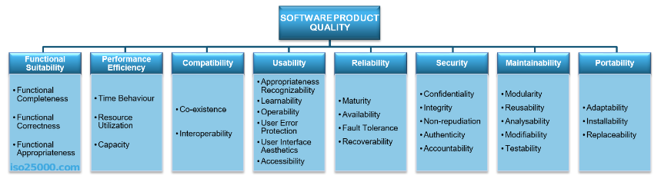

*Figure 2.* Software Quality Evaluation

*Source: bit.ly/3Wjn0dE*

**Functional Suitability** is the trait indicates how well a system or product satisfies explicit and implicit needs when used under predetermined circumstances.

**Compatibility** is the scope to which a product, system, or component can share data with other products, systems, or components and carry out its necessary functions within a shared hardware or software environment.

**Usability** is the level to which a product or system can be used by particular users to achieve particular goals with particular effectiveness, efficiency, and satisfaction.

**Reliability** is the degree to which a system, product, or component carries out specific functions in specific circumstances for a specific amount of time.

**Security** is the scope to which a product or system protects data so that authorized users can access it.

**Maintainability** is the quality reflects the degree of effectiveness and efficiency with which a system or product can be altered to make it better, fix it, or adapt it to shifts in the environment and user needs.

**Portability** is the transferability of a system, product, or component's effectiveness and efficiency when moving from one operational or usage environment to another in terms of hardware, software, or other factors.

## **Conceptual Model of the Study**

The Conceptual Model of the Study was designed to outline the possible actions of gathered thoughts or ideas. The general goal of the study is represented and composed in this way. This will guide readers, respondents, and users in understanding the study's development.

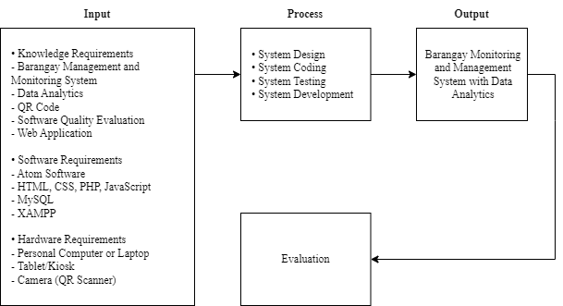

*Figure 3*. Conceptual Model of the Study

Figure 3 illustrates how the conceptual model served as a foundation for the project's progress. The requirements and tools are outlined in the input phase, which is subdivided into knowledge, software, and hardware requirements. Studies and ideas such rules, procedures, methods, and strategies are included in the knowledge requirements. The software requirements are the many software technologies needed to build the software system. The equipment required to run the system and other applications is referred to as hardware.

The process phase of software development includes system design, system coding, system testing, and system enhancement. Based on the collected input requirements, this phase specifies the approaches and designs using diagrams, flowcharts, and simple models. In order to guarantee the consistency of the system or program, the Barangay Monitoring and Management System's functionality and dependability were also verified and assessed using the ISO 25010 software evaluation instrument tool.

The study's result is the development of a Barangay Monitoring and Management System with Data Analytics.

## **Operational Definition of Terms**

To fully understand the study, the words referenced in this section were thoroughly explained.

**Figma -** is an effective design tool that enables you to create a variety of things, including apps, websites, and logos.

**Open-Source Text -** is source code that is made freely available for possible modification and redistribution. Products include permission to use the source code, design documents, or content of the product.

**GitHub -** is a web-based version-control and collaboration platform for software developers. Microsoft, the biggest single contributor to GitHub, initiated an acquisition of GitHub for $7.5 billion in June, 2018.

**Algorithms -** A process for solving a problem or completing a calculation is referred to as an algorithm. Algorithms are a precise set of instructions that perform defined operations in either hardware or software-based processes. Algorithms are frequently employed in all sectors of information technology.

**Raw Data -**  is data that has not been processed for use. A distinction is sometimes made between data and information to the effect that information is the end product of data processing.

**Electronic Records Management -** is using automated techniques to manage records regardless of format. Electronic records management is the broadest term that refers to electronically managing records on varied formats, be they electronic, paper, microform, etc.

**Local Area Network (LAN)** – is any group of computers and other devices that are connected to a server in a single place. LAN connections are used by devices to share resources.

# Chapter 3

# METHODOLOGY

This chapter contains project design, project development, operation and testing procedure, and evaluation procedure.

## **Project Design**

The Barangay Monitoring and Management System with Data Analytics aims to reduce barangay officials' workload. This system is for the benefit of the barangay and can be modified by the administrator, staff, and residents at any time. Here, it outlines the method for creating the approved study in order to achieve a practical and precise result. It outlines the tools, methods, and tactics for effectively conducting and attaining the stated objectives in order to produce successful and credible results.

**Context Diagram**

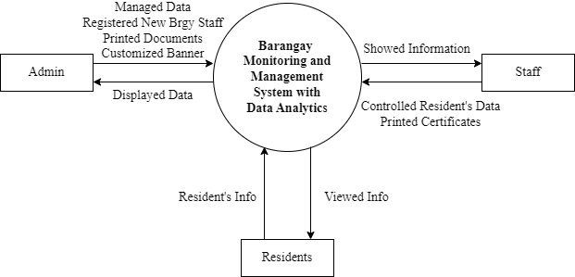

*Figure 4.* Context Diagram of the System

Figure 4 displays the three users connected to the system: the admin, staff and residents. The administrative task includes managing the citizen’s data, register new barangay staff account, print documents for residents, customize banner in the login page. Staff consist of controlling the resident’s credential and print requested certificates. The residents can view their information in the kiosk and register or update personal data to admin and staff. BMMS will display the data to all users.

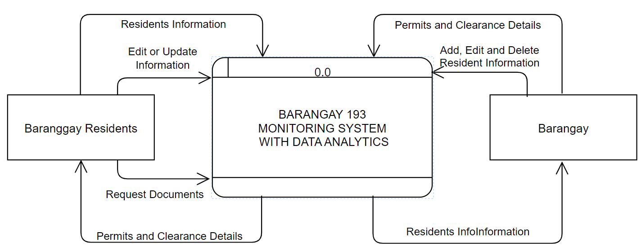**Data Flow Diagram (DFD)**

*Figure 6.1*. DFD level 0

**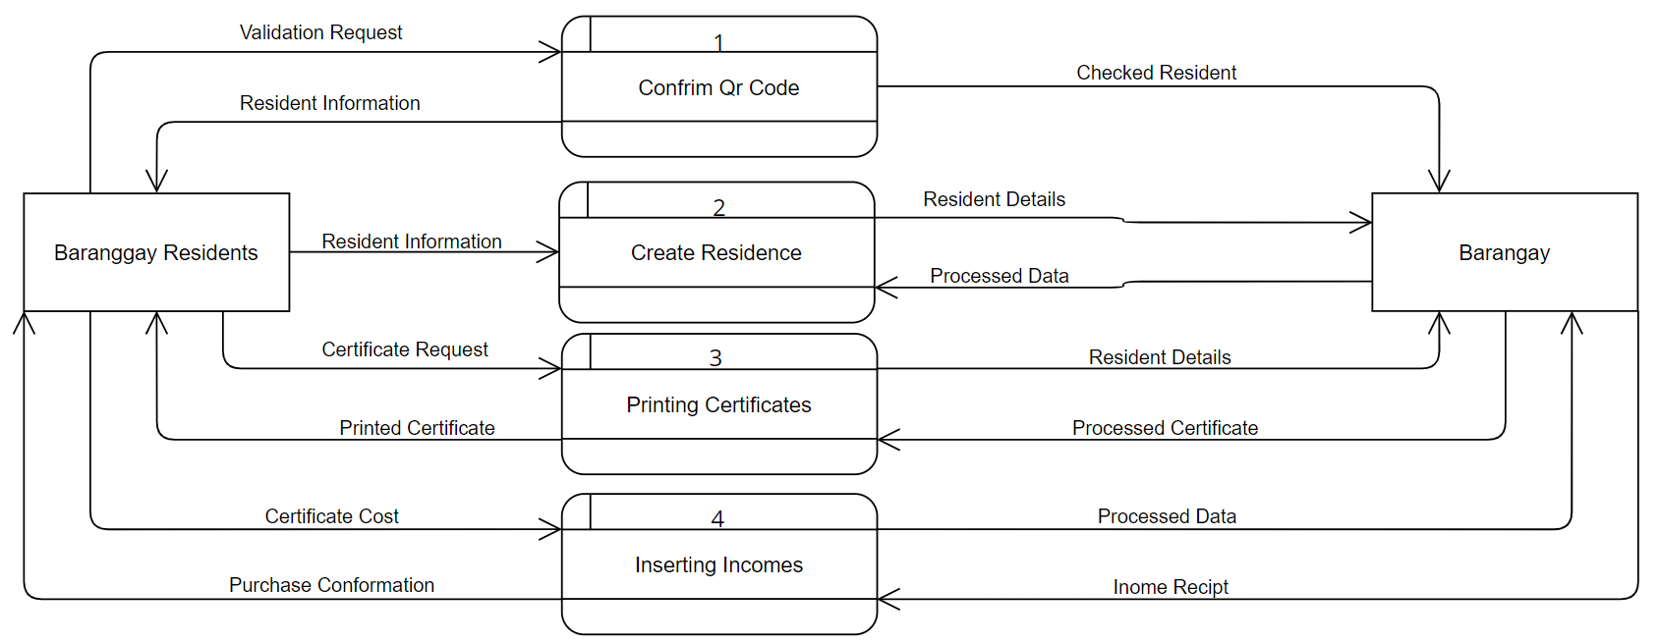***Figure 6.2.* DFD level 1

*Figure 6.3.* DFD level 2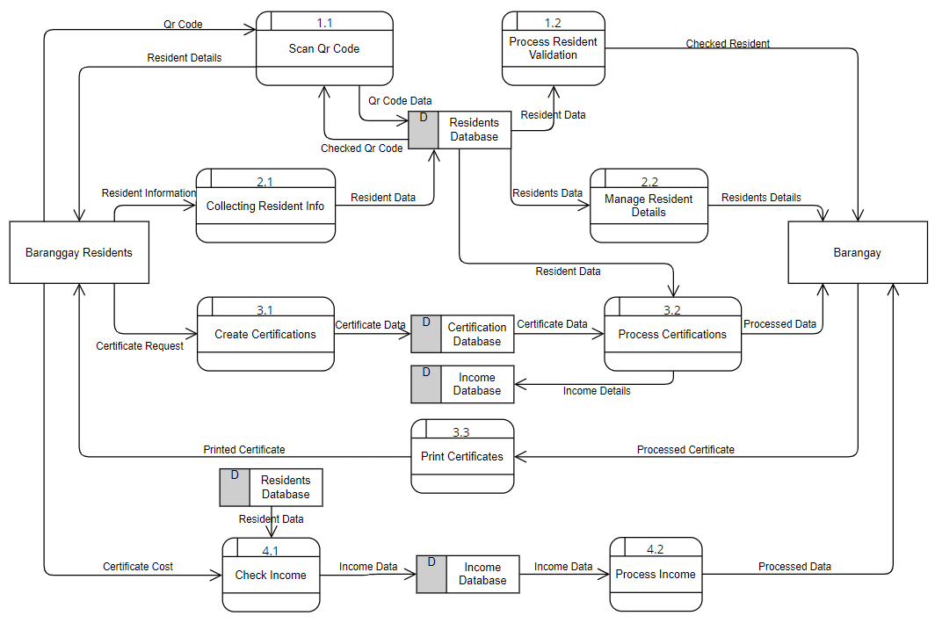

**Entity Relationship Diagram (ERD)**

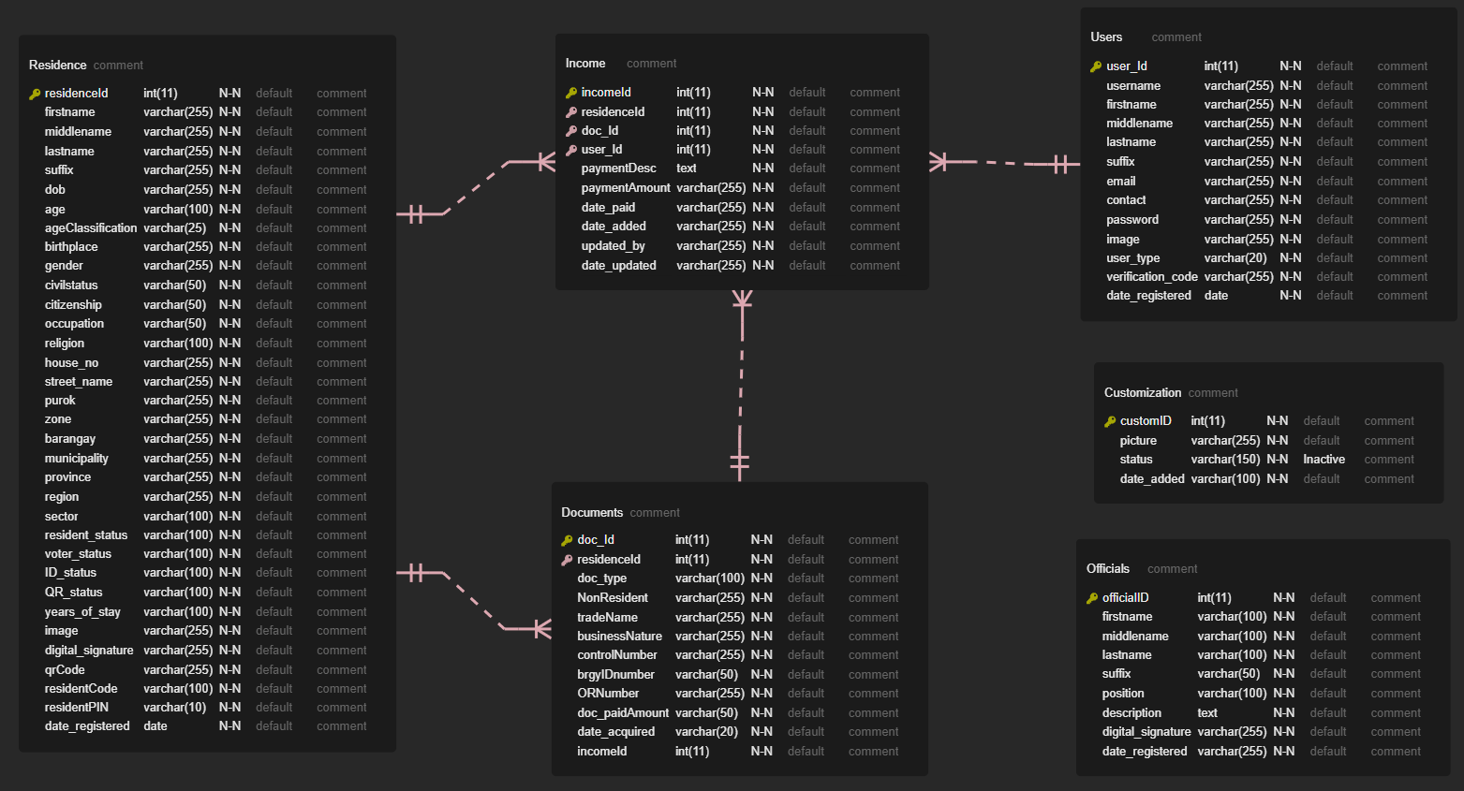

*Figure 7.* Entity Relationship Diagram

In figure 7, it shows the entity relationship diagram of the system. In residence, it displays the primary key which is “residenceId”. In income, it shows the “incomeId” as primary key and the foreign key is “residenceId, doc_Id, user_Id”. Documents primary key is “doc_Id” while the foreign key is “residenceId”. Users primary key is “users_Id” that contains the ID of the user. “customID” is the primary key for customization and lastly, the officials have “officialD” primary key.

**Use Case Diagram**

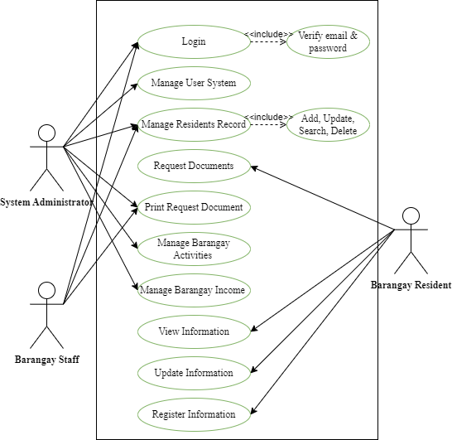

*Figure 9.* Use Case Diagram of the System

Figure 9 illustrates the Use Case Diagram for the system. With the use of lines and stick figures, a use case diagram illustrates the numerous ways that the system's and the target client's functionality can be presented and implemented. The target user is depicted in all of its components as seen in the figure.

The administrator identifies their role, such as logging in to the web-based application, print requested permits, run the user system, resident’s information, activities and barangay income. The staff indicates their function such as logging in, control the citizen’s data and print documents. The residents can request certificates, update and register personal information to the system users and view the data in the kiosk by scanning their unique QR Code.

**System Architecture**

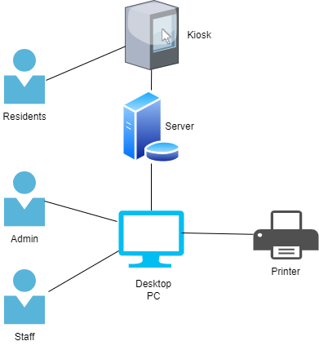

*Figure 10.* System Architecture Diagram

Figure 10 shows the system's structural design. System architecture consist of different devices such as computer, printer and kiosk. Desktop and kiosk is connected to server which store the personal data of the residents. Staff and admin is authorized to add, update, delete information to the system while resident can see their personal data in the kiosk by scanning the unique QR Code.

## **Project Development**

The system's blueprint and foundation will be displayed in this phase, which will be followed by the steps that must be taken in order to successfully operate the system. Here, it illustrates how to create a barangay monitoring and management system with data analytics to ensure the system's correct operation. It provides a step-by-step breakdown of the output polishing process. This will detail the design processes in detail for an excellent outcome.

**Software Development Life Cycle**

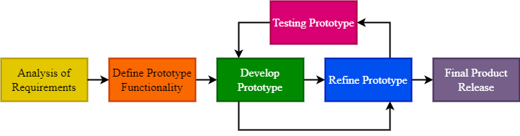

*Figure 11.* Prototype Development Model

The proponent follows the standard SDLC process to develop and present solution for identified problems using the prototype development. For this project, the researcher used the six-phased system prototype methodology illustrated in figure, which requires for multiple tests and improvements of the system prior to its official release. The basic stages of system development process are divided into six main components.

**Analysis of Requirements**

During this step, the researcher visited the site in person with the target community to discuss the necessary conditions for a formal consent letter, shown in Appendix D, to be sent one week into the project before the appointment.

**Define Prototype Functionality**

In this stage, the researcher determined the target users and the components that should be created for them. The barangay secretary or admin, barangay staff and residents' roles will be defined by barangay management information system.

**Development of Prototype**

The development of the system was done using HTML, CSS, PHP, JavaScript programming language and MySQL. It combines the administrative duties of the barangay secretary with those of the barangay personnel and the residents. Additionally, the modules of the system must be developed in accordance with the roles that have been assigned to each barangay authority.

**User Testing and Feedback**

Each module has gone through testing to identify any operational or functionality bugs so they may be fixed as soon as feasible. Depending on the availability of the intended users, the testing phase was carried out in January 2023. Evaluation tools were used to evaluate how satisfied users were with the usability and functionality of the system in order to assess user satisfaction levels further.

**Refine Prototype**

To further align system functionalities with user needs, each module has undergone prototype refinement. This was created by conducting additional testing up until goals were achieved.

**Final Product Release**

The system will be introduced to the intended community for use after final testing and/or refinement. In addition to doing a formal orientation, users must also receive vital notice of instructions before the final release in the form of a user's manual.

**Site Map**

**Admin**

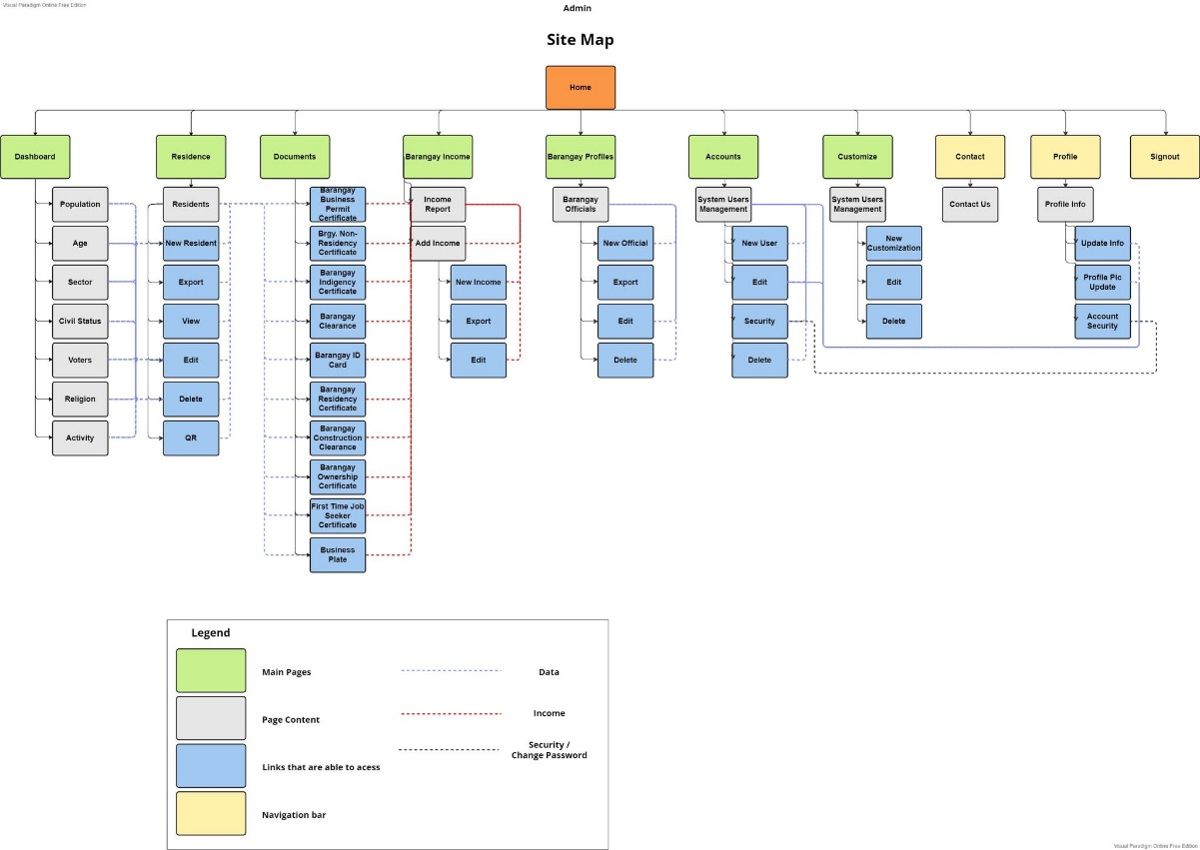

*Figure 12.* Admin Site Map

**Staff**

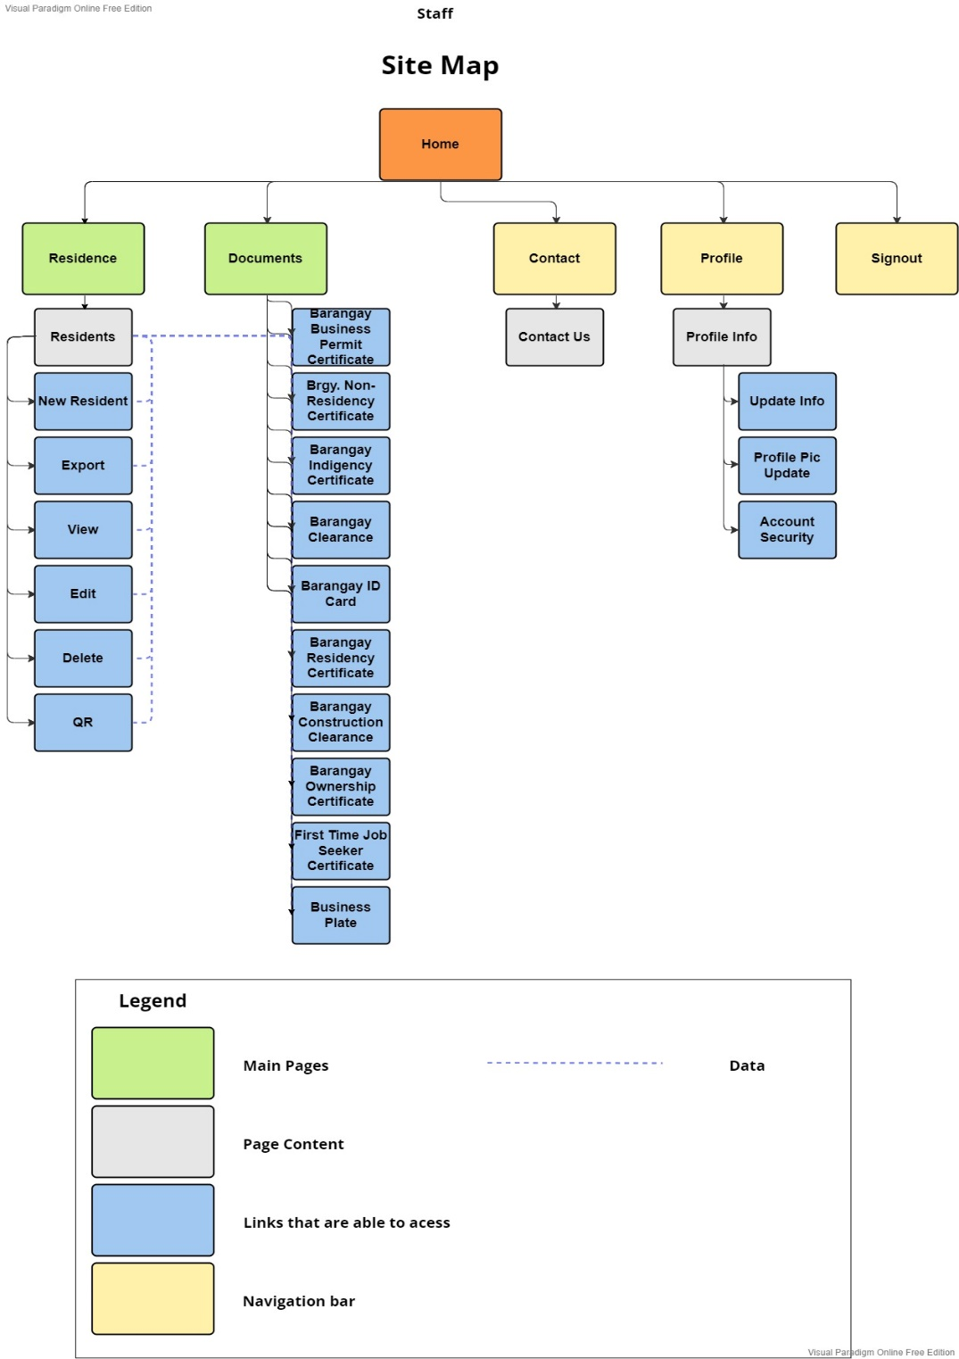

*Figure 13.* Staff Site Map

## **Operation and Testing Procedure**

The intended users will evaluate the performance, dependability, and accuracy of the designed barangay monitoring and management system with data analytics that achieved the intended research objectives and execution through the web application. Performance of the system will be guaranteed through the use of numerous tests and their execution. The Barangay 193 – Zone 20, Pasay City admin, staff, and residents will benefit from the installation of this system.

Admin and staff can control the residents’ data and documents. Citizen have their own QR code once they are registered to the system and they can scan it to the kiosk. Once the kiosk verifies their QR code, their personal information will display. To provide improved system execution, testing phases for a functional, consistent, and accurate performance will be present. For each phase, there are effective procedures:

1. Created information based on the function's description.
2. Data perception is based on the function's description.
3. Execute the cases and review them.

**Functional Testing**

To examine the system's highlights or features, functional testing was conducted. It will ensure that each software component produces the desired results. Every occurrence was presumptively treated as the following technique.

**General Functional Testing**

1. Identify the web application's features.
2. The researchers produced input data based on the demands of the function.
3. The researchers were able to determine the output data based on the requirements of the function.
4. The test cases were run by the researchers.
5. The researchers made a comparison between the actual and predicted results.
6. The postcondition was determined.
7. They determined if the test was successful or not.

An organized structure of test cases was used to document each functional test. Analyzing the results allowed us to assess the system's efficacy. In Table 1, you will see an example test case form that was utilized in the system's testing and evaluation.

Table 1.

*Test Case Form*

|  |  |
| --- | --- |
| Test Case | Test Case Answer |
| Test Suite ID | BMMS-01 |
| Test Case ID | BMMS-Admin-01 |
| Test Case Summary |  |
| Related Requirement |  |
| Prerequisites |  |
| Test Procedure |  |
| Test Data |  |
| Expected Result |  |
| Actual Result |  |
| Status |  |
| Remarks |  |
| Created By | GROUP 1 |
| Date of Creation |  |
| Executed By |  |
| Date of Execution |  |
| Test Environment |  |

* Test Suite ID – The BMMS Suite ID was used for this investigation, followed by the tally number method.
* Test Case ID - The BMMS-(role)-number is the test case ID used for this evaluation.
* Test Case Summary - The test case's objective or general structure.
* Related Equipment - The ID of the need to which this test case is related.
* Prerequisites - Any conditions or prerequisites that must be met in order for the test to be run.
* Test Procedure - Rules for performing feature test scenarios.
* Test Data - The assessment will make use of the test data, also known as reference data.
* Expected Result - The expected results will be shown given the testing procedures.
* Actual Result - The precise outcome of the testing strategy as communicated by the designated user or the tester.
* Status - Either succeed or fail. If testing is delayed, the position will be marked as "Blocked", and if testing is not completed, it will be marked as "Not Executed".
* Remarks - This structure is for suggestions, comments, or other input.
* Created By - The name of the researcher or programmer who created the test case.
* Date of Creation - The day that the test was conducted.
* Executed By - The individual responsible for validating the associated Test Suite ID.
* Date of Execution - The day the evaluation was completed.
* Test Environment - Networks, hardware, or software are frequently involved.

Table 2.

*Over-all Summary of Functionality Test Cases*

|  |  |
| --- | --- |
| **Use Case** | **Total No. of Test Cases** |
| Barangay Admin  Barangay Staff | 35  12 |
| Barangay Residents | 3 |
| **Total** | **50** |

In Table 2 above is the number of test cases developed to evaluate each module's success. Test cases were executed, and each case's results were recorded, indicating whether the test case was successful or unsuccessful as demonstrated in Table 3. When a criterion is satisfied, it means that the results were what was expected. The failed condition, on the other hand, shows that the case was handled incorrectly or that the actual outcomes were unexpected.

Table 3.

*Test Execution Summary*

|  |  |  |  |
| --- | --- | --- | --- |
| **Test Execution** | **Expected Result** | **Actual Result** | |
|  | | **Cycle 1** | **Cycle 2** |
| No. of Test Cases Executed | 100% |  |  |
| Passed | 100% |  |  |
| Failed | 0% |  |  |
| No. of Test Cases Not Executed | 0% |  |  |

In table 3, 50 test case scenarios made up the general component test case in this examination. When a basis is satisfied, it indicates that the outcomes were correct and consistent with expectations. The failed criterion demonstrates that the case was improperly concluded or that the results were not generally anticipated.

**Accuracy Testing**

Analyses of the false-negative, true-negative, true-positive, and false-positive test outcomes as well as the system's accuracy and precision were conducted. To calculate the reliability, the following equation is Confusion Matrix was used:

$$Accuracy= \frac{TP+TN}{TP+TN+FN+FP} x 100$$

*Source: http://bit.ly/3I2S51l*

As shown in Table 4, if the test case pauses, the problem is noted in a test log. To check that the problems are resolved, an incorrect case deformity will be corrected, and the related case will be run in a new cycle.

Table 4.

*Test Incidents Log*

|  |  |  |  |  |
| --- | --- | --- | --- | --- |
| No. | Error Description | Test Case ID | Severity | Priority |
| 1. |  |  |  |  |
| 2. |  |  |  |  |
| 3. |  |  |  |  |
| 4. |  |  |  |  |

The depth ranking and vita levels that were affected by an error were shown in Table 5.

Table 5.

*Error Priority Levels and Severity Classification*

|  |  |  |
| --- | --- | --- |
| **Severity** | **Description** | **Priority** |
| Critical | This error suggests that the process has been totally stopped and that no more steps can be taken. | High |
| Major | The system fails because of this critical flaw. But some parts of the system are still functioning. | Medium |
| Minor | As a result, there won't be any significant system failures. | Low |

In Table 5, it displays the error priority levels and severity classification. A defect would represent a priority, indicating how quickly it needs to be corrected. Severity is the impact of a defect on the system would be determined by how serious it is.

**Reliability Testing**

This test was used to evaluate how well the system operated under specific ordinary conditions. The following actions were taken:

1. Run the Barangay Monitoring and Management System with Data Analytics in various internet browser and access web application on different computer or laptops.
2. The total number of cases that fail and the total number of cases examination were both included.
3. The failure probability was determined.

## **Evaluation Procedure**

To determine whether the objectives had been attained, the system's performance was examined and reviewed. 15 barangay employees and 3 barangay residents who responded to the survey were the prospective users. The ISO/IEC 25010 software evaluation form's uses is demonstrated in Appendix A. This instrument served as the assessment criterion for measuring the system's performance.

The following actions were taken to evaluate the results of a study:

1. The respondents were informed of the purpose of the study and given an explanation of it, and a face-to-face demonstration of the system's utility was used to introduce it.
2. In accordance with the evaluation criteria specified in ISO/EIC 25010, as shown in Table 6, respondents were asked to rate the system using a numeric rating scale of 1-4, with 5 being the highest and 1 being the lowest.

Table 6.

*Likert Scale in Evaluating the System*

|  |  |
| --- | --- |
| Scale | Descriptive Rating |
| 5 | Highly Acceptable |
| 4 | Very Satisfactory |
| 3 | Satisfactory |
| 2 | Fair |
| 1 | Poor |

In table 6, it shows the Likert scale in evaluating the system. 5 is the highest scale and it means “Highly Acceptable”, the lowest scale is 1 which means “Poor”.

# Chapter 4

# RESULTS AND DISCUSSION

The results of the research investigation are included in this section. It compromises the project's structure, description, test findings, capabilities, and evaluation.

## **Project Description**

The Barangay Monitoring and Management System with Data Analytics (BMMS) is a website application developed to identify, arrange, predict, and modify datasets of the barangay’s information these include and not limited to, personal information, barangay identification, certificates, barangay income records, and so on.

The BMMS is a data collection and analysis system designed to help barangay officials better understand the needs and demands of their constituents. The project aims to provide barangays with a platform to monitor, manage, and analyze data related to their local communities, that could help the barangay make data-driven decisions that will help improve the quality of life for their constituents. The BMMS was intended to be used in Barangay 193, Pasay City with the objective of upgrading the filing system of the barangay into a more modern system of maintaining information with its features that could help and improve the process of registering a new information to the barangay archives, further improvements regarding possible issues with user errors and resident protections has been implemented to assure the resident and barangay staff of possible data breaches, the Barangay Monitoring and Management System is a local database system with a kiosk for the resident to access their needed information and request possible changes or printout a document from the barangay but before the resident can access the information they need to input a pin code that they have registered once they have obtained their Barangay ID’s, there are two accounts with specific privileges that are dedicated to the web application, Firstly the admin which can access all data from the website from the website’s banner to each accounts that was designated to each staff, the next account is the staff which was modified to include only what was asked by the barangay official secretary, the website application is to be used on their local computer’s. Ultimately, the goal of the Barangay Monitoring and Management with Data Analytics is to empower barangay officials with the tools and insights they need to make informed decisions and better serve the needs of their communities. With this project, barangay can become more proactive and responsive, ensuring that they are providing the highest quality of life for their constituents.

## **Project Structure**

The following screenshots presents the project structure of Barangay Monitoring and Management System (BMMS).

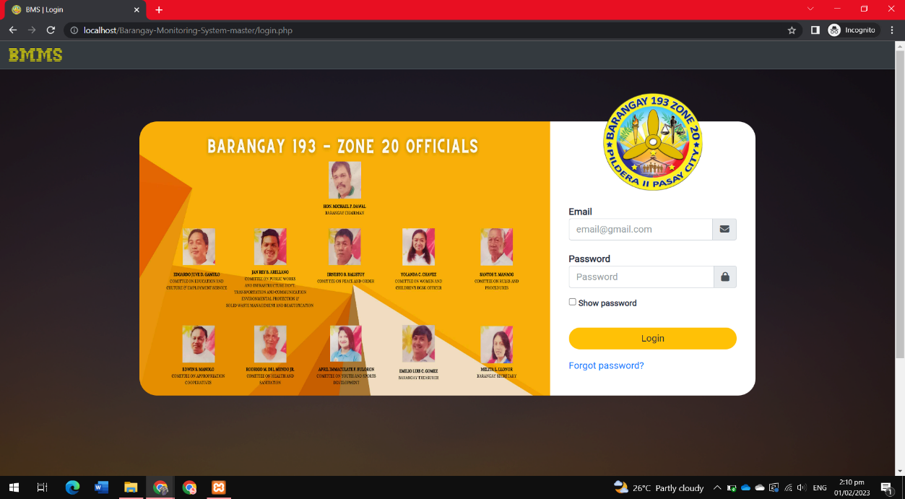

*Figure 14.* BMMS – Login Page (Admin)

Figure 14 shows the login form where administrators and staff members can log in using their registered email and passwords. To login, press the “Login” button after the user input their registered account. When finished, dashboard page will be displayed. Also, users can also use the forgot password to reset their password by clicking the “Forgot the password” then the verification code will be sent to the email.

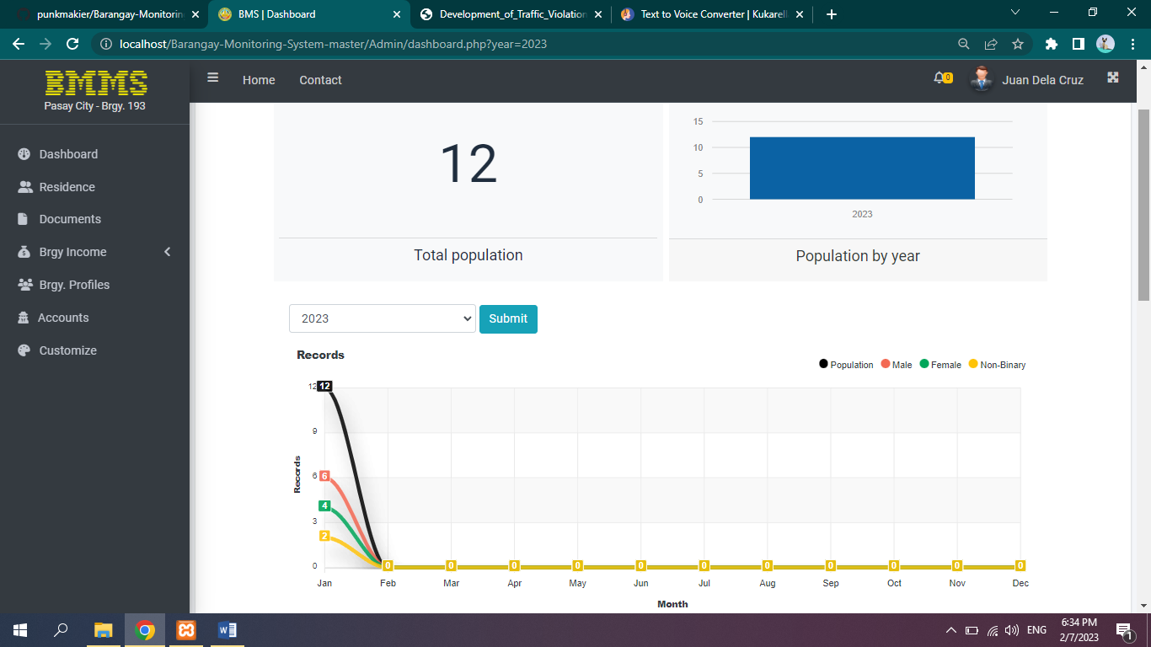 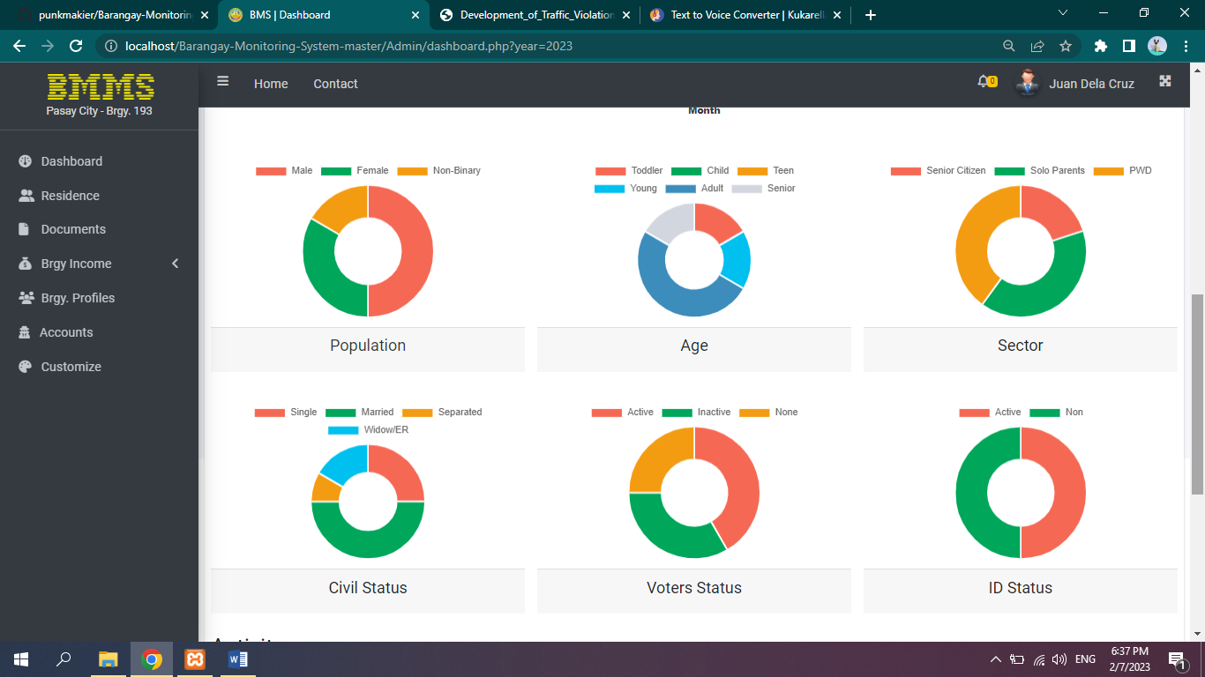

*Figure 15.* BMMS - Dashboard Page (Admin)

Figure 15 display the dashboard that Admin allow to monitor the number of total population, bar graph of population by year, pie chart with categorized data and line graph to analyze the population. The number will display when the cursor of the mouse point to the different color in pie chart. In the left corner is the notification bell for activities in barangay and sidebar menu that display different navigation menu while on the upper right corner will locate the user’s profile and logout button. If the user clicks the “Home” under the name of user, it will directly to the dashboard page.

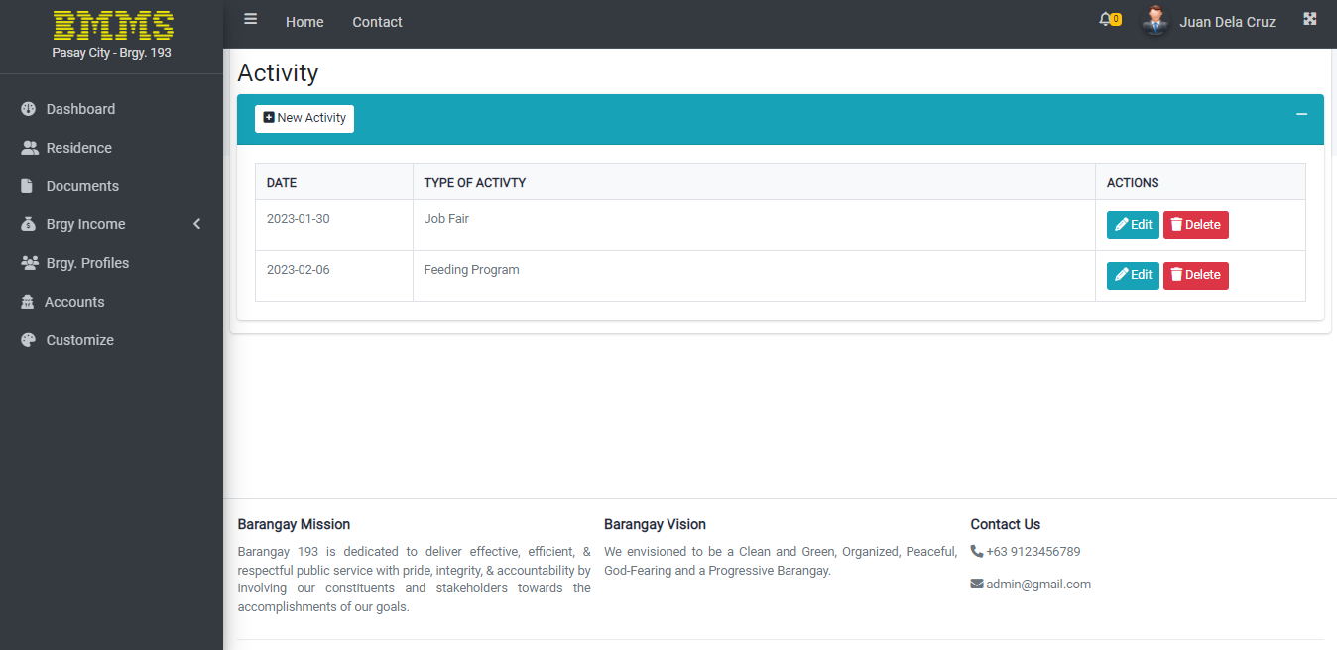

*Figure 16.* BMMS – Activity in Dashboard Page (Admin)

Figure 16 showcase the activity in barangay wherein the Admin can add, edit and delete activities in barangay. The bell icon in the upper right corner will notify the Admin if the activity is need to accomplish on that day.

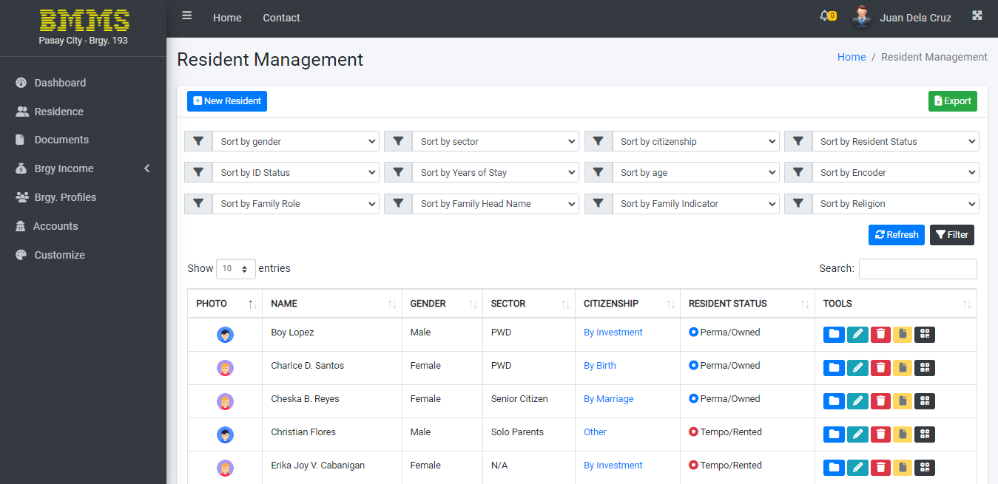

*Figure 17.* BMMS - Residence Page (Admin)

Figure 17 presents the list of the residents registered in the system. On the upper left corner, the user can add residents while on the upper right corner is the export excel file that can download the data of the citizen. User can sort the data by clicking the gender, sector, citizenship, resident status, ID status, years of stay, age, encoder of the system, family role, family head name, family indicator, and religion.

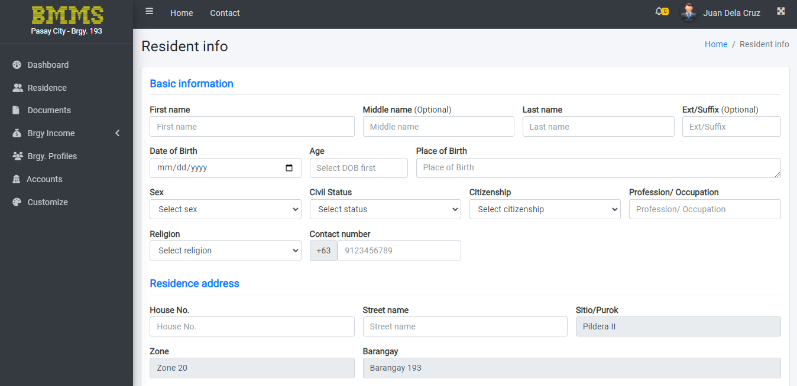*Figure 18.* BMMS - Add New Resident (Admin)

Figure 18 illustrates the required field for creating information to the householder.

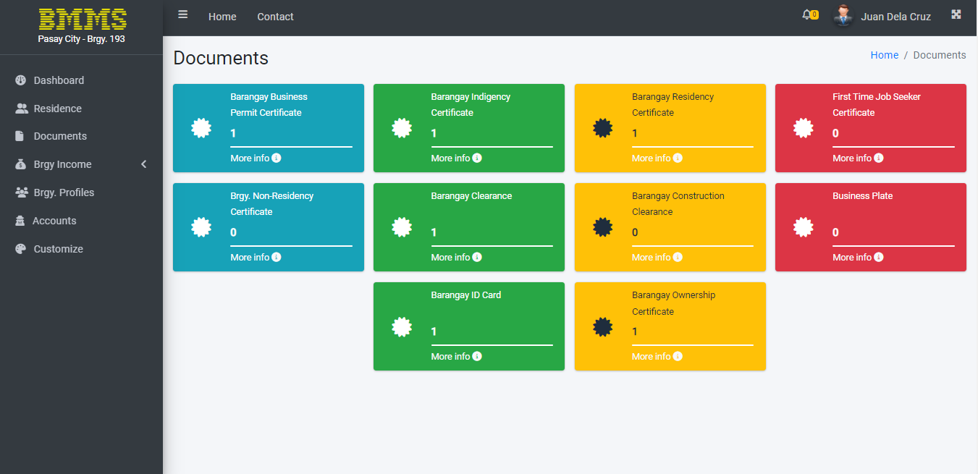

*Figure 19.* BMMS - Documents Page (Admin)

Figure 19 presents the different barangay certificates, permits, and ID. By clicking the certificates, required fields will be displayed. The number below in the document title indicates the total requested by the residents.

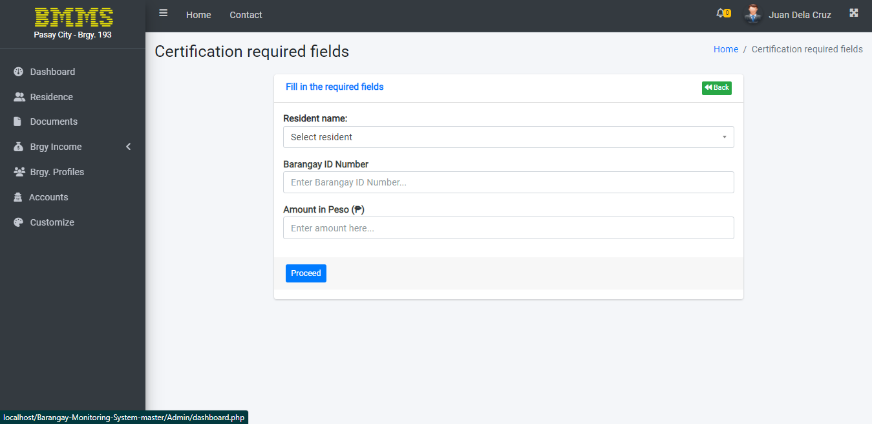

*Figure 20.* BMMS - Sample Required Field for Documents (Admin)

Figure 20 portrays the mandatory fields that need to do by user before proceeding to print the permits.

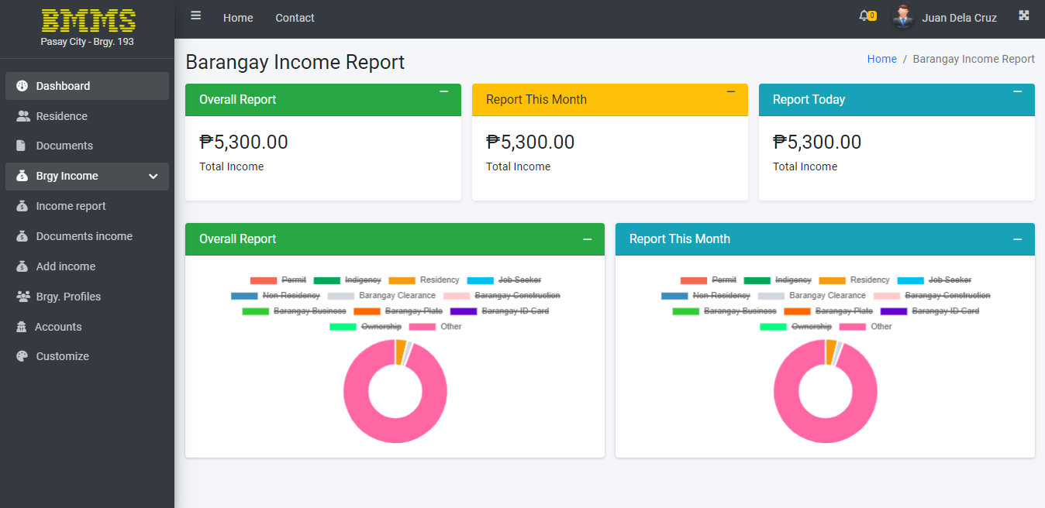

*Figure 21.* BMMS - Barangay Income Report (Admin)

Figure 21 presents the all barangay income report. In the pie chart if the certificate doesn’t have any record of transaction, the name of the permit above the graph will have cross line that indicates zero report. User can monitor the total of documents by pointing the pointer of computer mouse in the different color of pie chart.

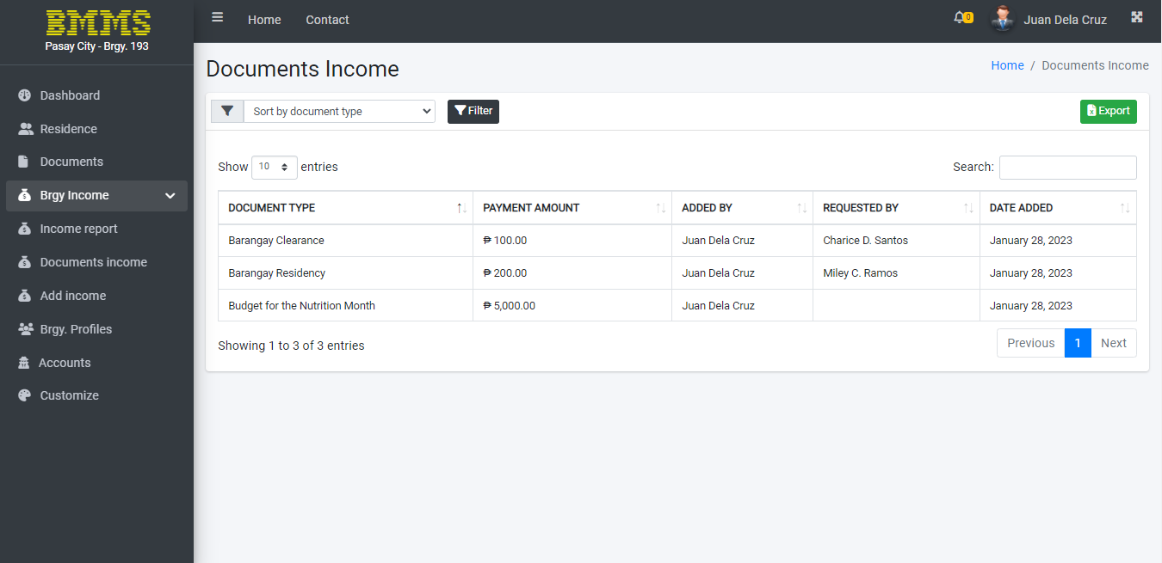

*Figure 22.* BMMS - Barangay Document Income (Admin)

Figure 22 displays the list of all document income. Users can sort the document by clicking the sort tab on the upper left corner then click the “filter” to process the document that want to categorized. On the upper right side, user can have a file report of the income by clicking the “Export” tab.

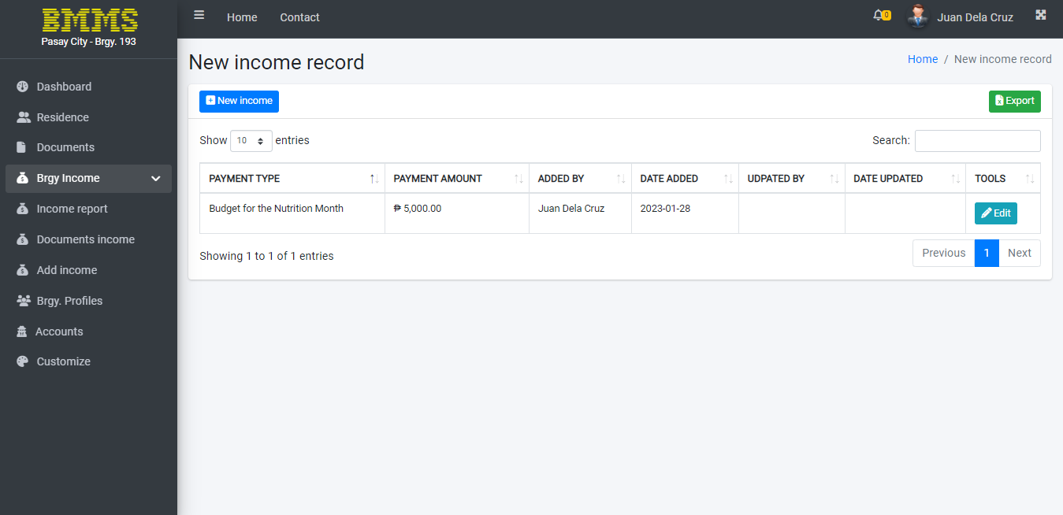

*Figure 23.* BMMS - Barangay Income Page (Admin)

Figure 23 expose the creating new income report in the system. “New Income” button on the upper left edge. User can export excel file by clicking the “Export” button on the upper right side.

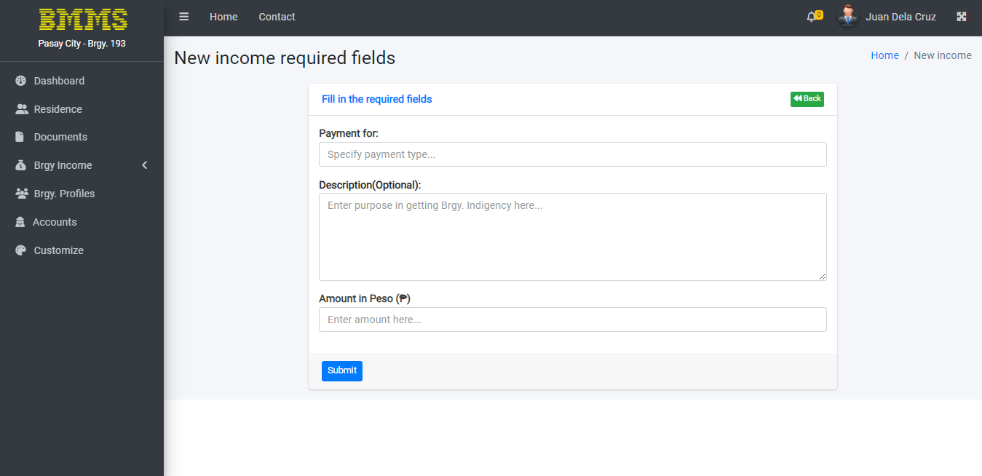

*Figure 24.* BMMS - Add Other Barangay Income (Admin)

Figure 24 shows the required form to the user to record a new barangay report. Click “Submit” button after answering the fields.

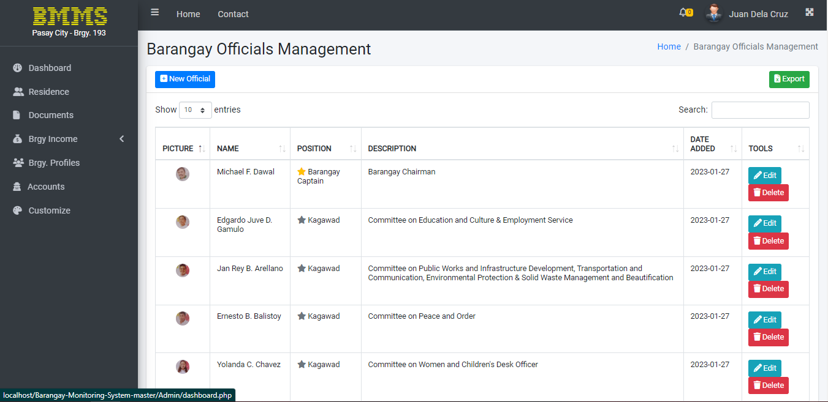

*Figure 25.* BMMS - Barangay Profiles Page (Admin)

Figure 25 presents the all listed barangay officials. Admin can add, edit and delete the information of the employees.

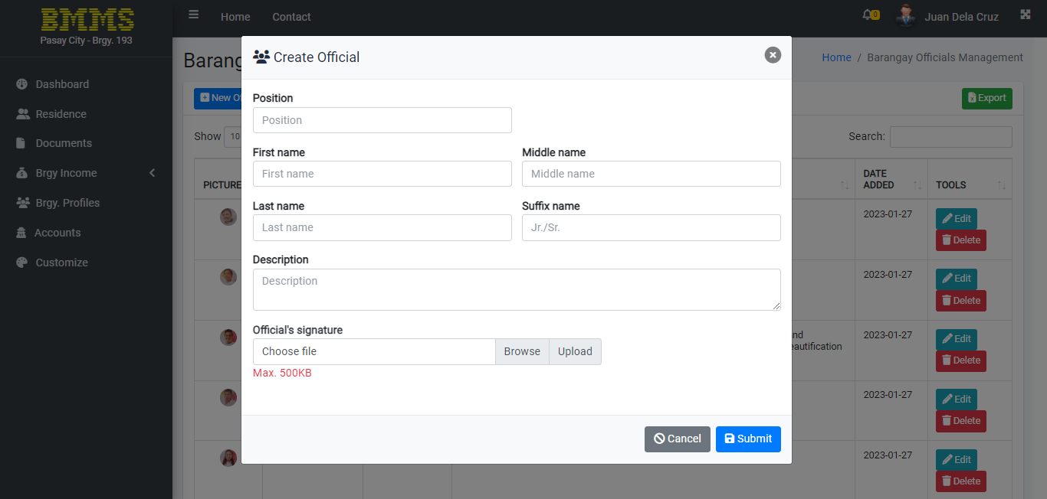

*Figure 26.* BMMS - Create New Official (Admin)

Figure 26 demonstrate the required form for adding a new barangay official.

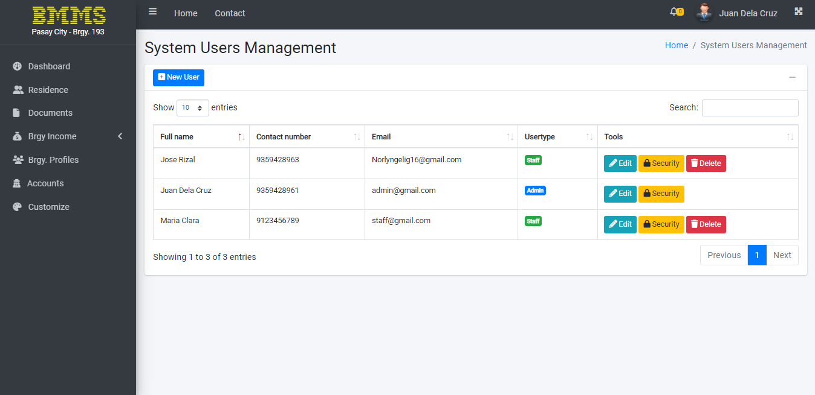

*Figure 27.* BMMS - Accounts Page (Admin)

Figure 27 exhibit the list of all users in the system. Admin can edit, change the password, and delete the staff account.

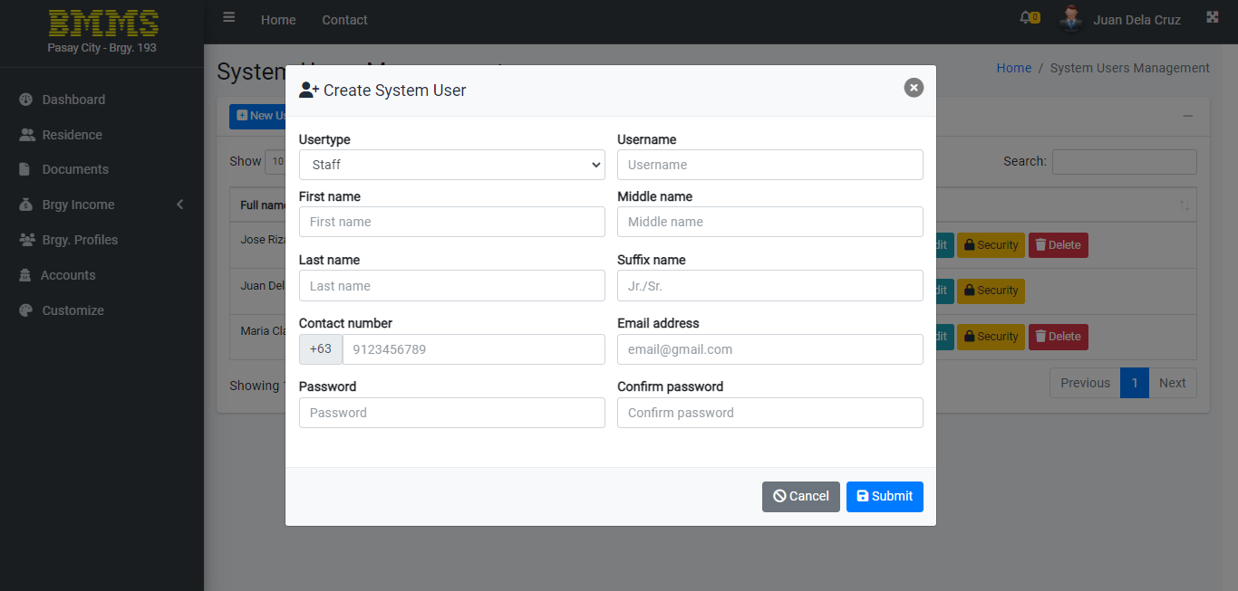

*Figure 28.* BMMS - Create System User (Admin)

Figure 28 presents the form for making a new user account.

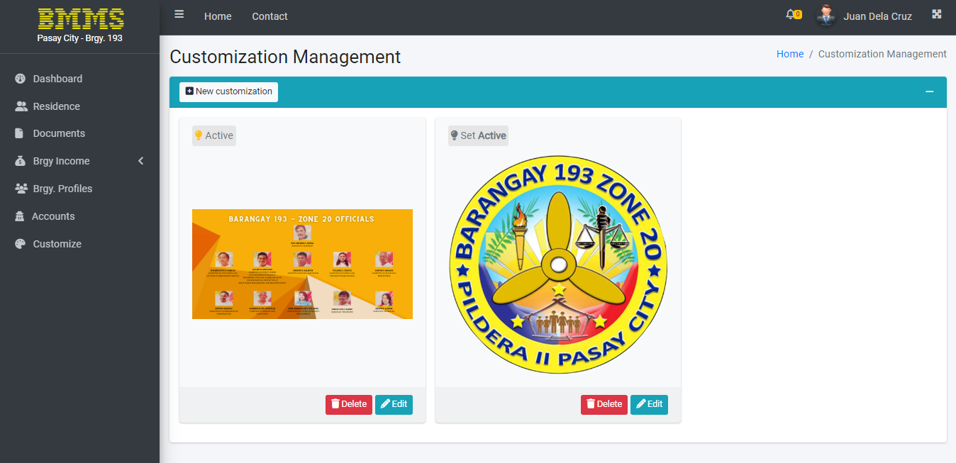

*Figure 29.* BMMS - Customize Page (Admin)

Figure 29 display the customize banner for login page. Admin can change the cover photo of the system by clicking the “New Customization” tab in the upper left corner. User can also edit and delete the banner.

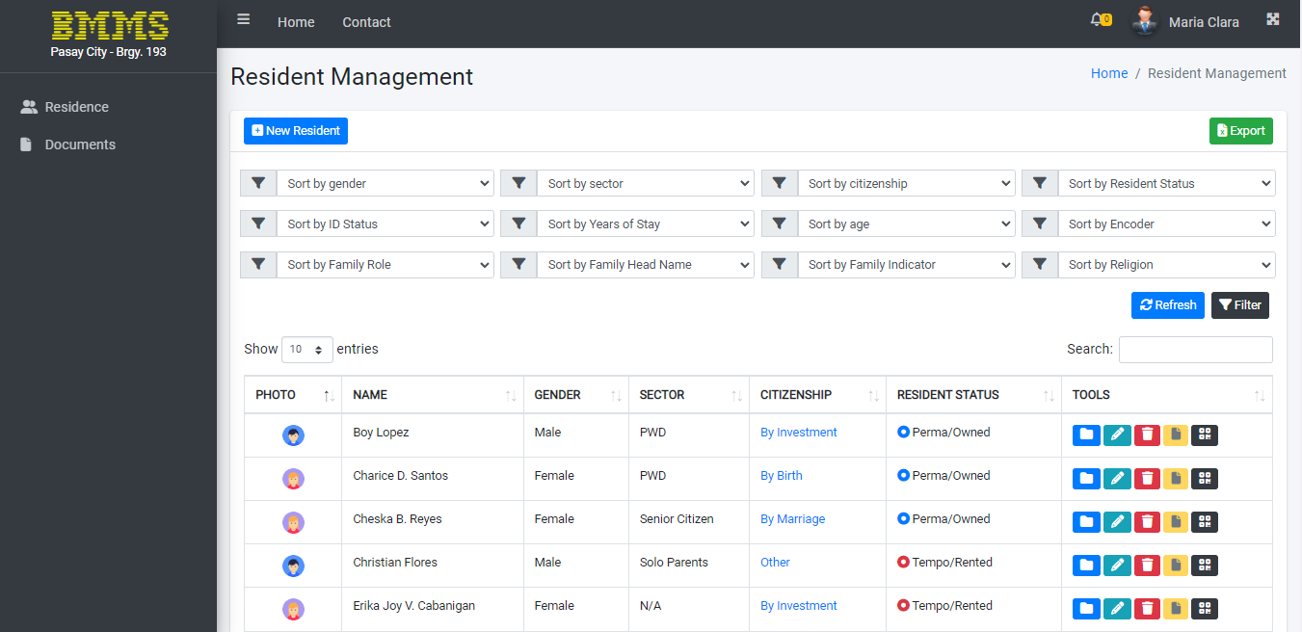

*Figure 30.* BMMS - Residence Page (Staff)

Figure 30 shows the list of residents. Staff can add, sort and export excel file of a residents’ data.

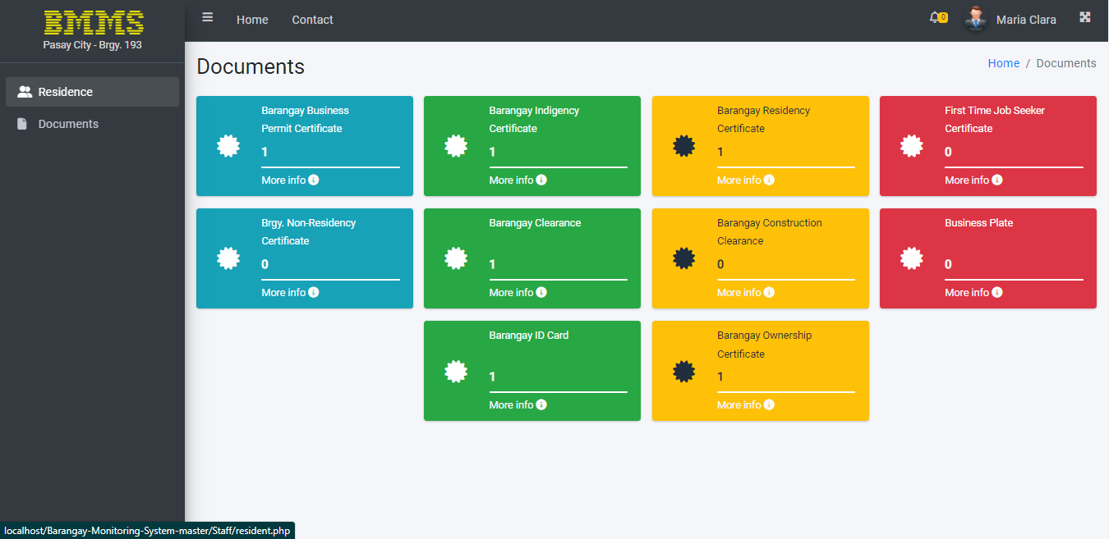

*Figure 31.* BMMS - Documents Page (Staff)

Figure 31 showcase the different documents that can be requested by the citizens. Staff can also monitor how many permits they produced to the inhabitant.

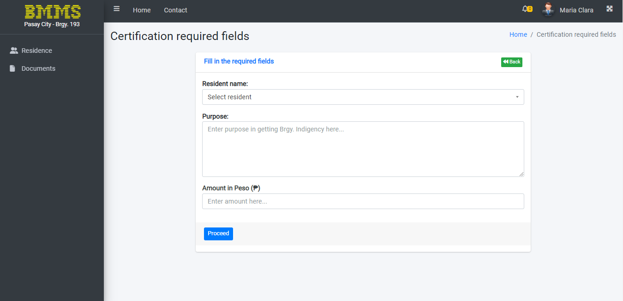

*Figure 32.* BMMS - Required Fields for Documents (Staff)

Figure 32 illustrates the essential form before to move on the printing documents.

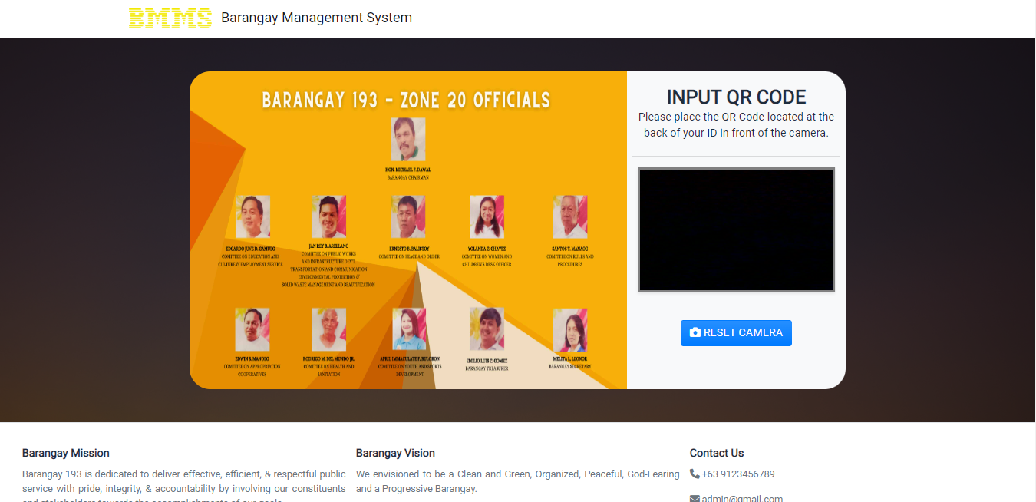

Figure 33. Kiosk Page (Residents)

Figure 33 shows the Kiosk page. Resident can scan their unique QR Code to display the information in the system. Citizen can update the data by telling to admin or staff. To open the camera of the kiosk, resident should click the “RESET CAMERA”. On the bottom of the page it will display barangay mission, vision and contacts.

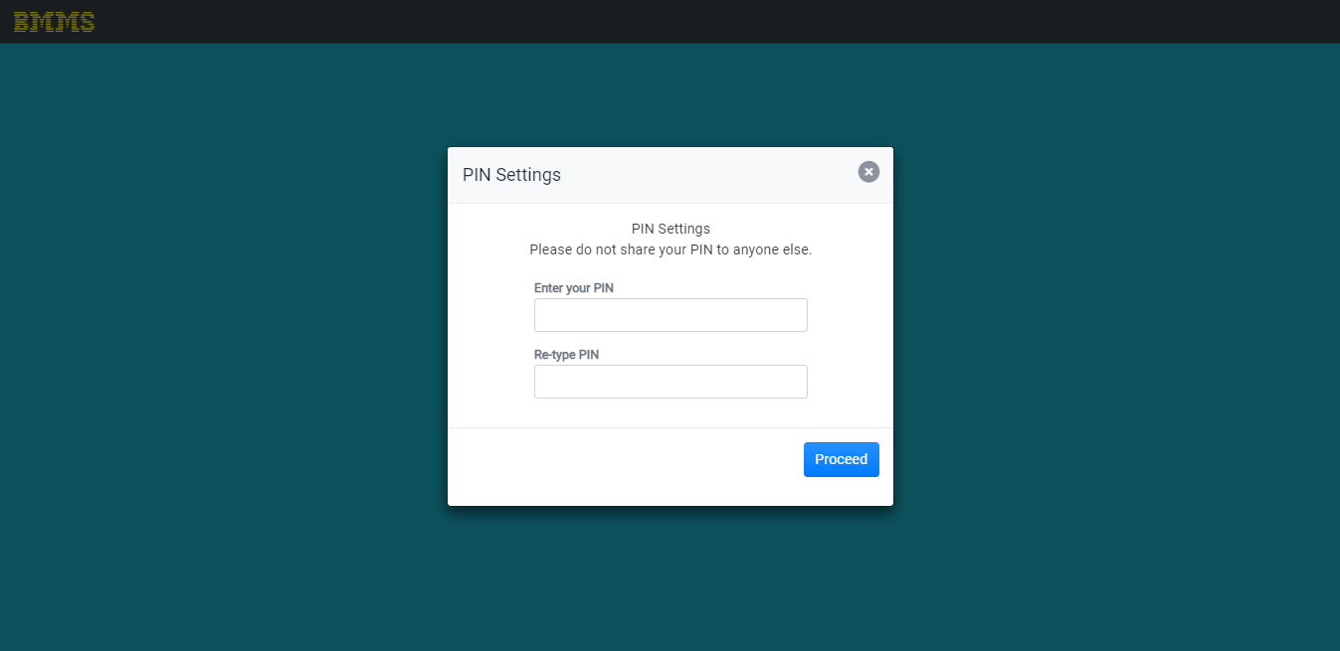

Figure 34. Set PIN Code in Kiosk (Residents)

Figure 34 showcase the PIN Settings for first time scanning the QR Code. Resident should put a PIN Code to secure their information after scanning the QR Code.

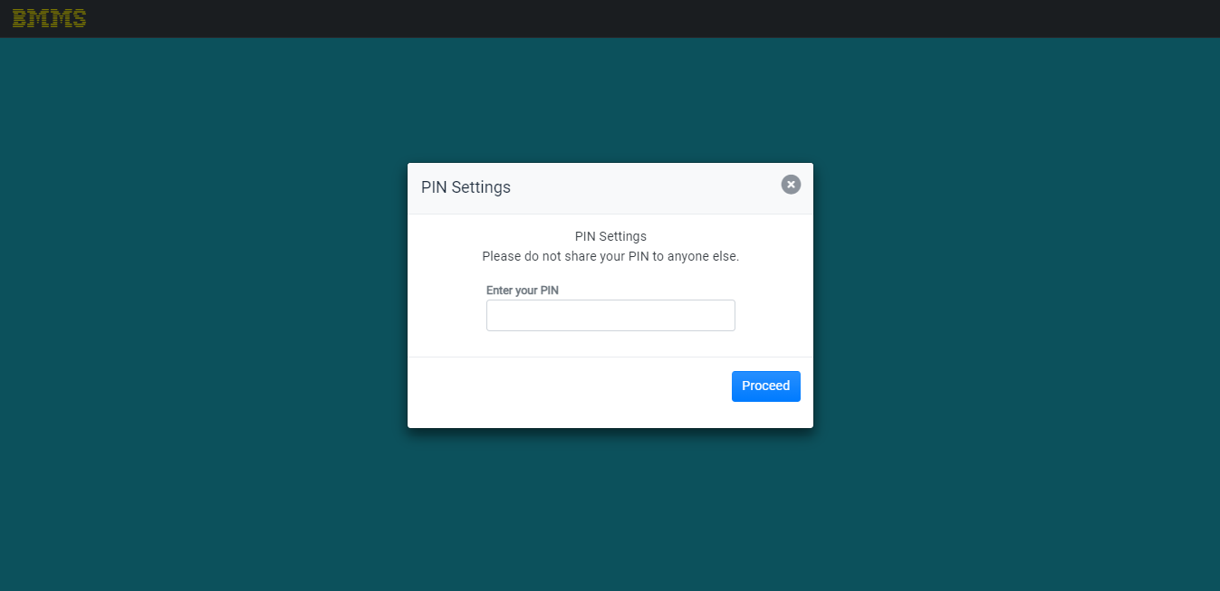

Figure 35. Enter Registered PIN Code in Kiosk (Residents)

Figure 35 display the PIN Settings for the resident who already have registered PIN code. After the citizen input the PIN, it will be directly display their information.

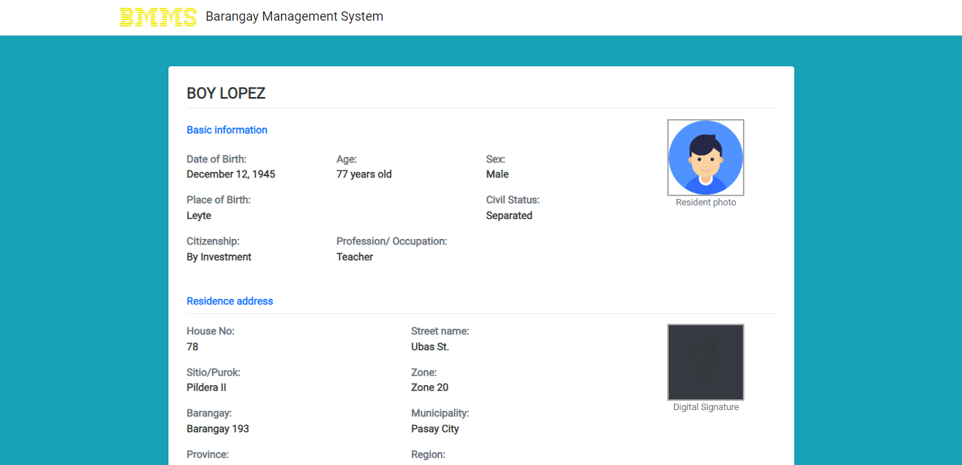

Figure 36. Display Information in Kiosk (Residents)

Figure 36 shows the information of the citizen after the PIN successfully verified. If the system is idle for 5 minutes, it will automatically exit to kiosk QR scan page.

## **Project Test Results**

This part provides a summary of the test execution summary and the obtained data based on testing for functionality, dependability, and accuracy.

**Functionality Test Results**

The system's features, functions, and specification requirements were tested using the functionality testing method. To confirm that the system and application met the necessary standards for quality and procedure, this test was completed and put into action. To guarantee that the system's functionality, completeness, and accuracy have been fully completed, a total of 50 functionality test cases have been run. Table 8 illustrates the test execution.

In short, this indicates the proportion of test cases that were completed, passed, failed, or were not executed at all.

Table 8.

*Functionality Test Execution Summary*

|  |  |  |  |
| --- | --- | --- | --- |
|  |  | Cycle 1 | Cycle 2 |
| No. of Test Case Executed | 50 | 100% | 100% |
| Results of Test Case |  |  |  |
| Passed | 100% | 100% | 100% |
| Failed | 0% | 0% | 0% |
| No. of Test Cases Not Executed | 0 | 0% | 0% |

The findings for the functionality test are compiled in Table 8 for ease of reference. According to actual results, in cycle 1, every test case was conducted, 100% of them passed, 0% of them failed, and not a single test case was skipped. This demonstrates the effectiveness of the testing for the initial cycle. Even though the system was successful in the first cycle, a second cycle was run for better data to make sure the test cases produced accurate results and that no errors or flaws would be discovered. Actual test results from the second cycle revealed that all test cases passed with a score of 100 percent; this demonstrated the accuracy of the results from the first cycle and the success of the functionality testing.

**Accuracy Test Results**

Accuracy testing was used to ensure that the system and application could give correct data and results for calculating the accuracy of the system and application. The testing of accuracy included true positive (TP), false positive (FP), true negative (TN), and false negative (FN) results, which were reported and shown on a confusion matrix.

Table 9.

*Accuracy Test Results Summary*

The accuracy results are plotted by the use of Confusion Matrix.

|  |  |  |
| --- | --- | --- |
|  | Positive (actual) | Negative (actual) |
| Positive (predicted) | 50 | 0 |
| Negative (predicted) | 0 | 0 |

Accuracy Results:

$$Accuracy= \frac{TP+TN}{TP+TN+FN+FP} x 100$$

TP = 50, TN = 0, FP = 0, FN = 0

$$Accuracy= \frac{50+0}{50+0+0+0} x 100$$

Accuracy = **100%**

The results of the system's accuracy rate were validated using accuracy testing, which was based on the test cases outlined in Appendix E. The true positive result was 100, the true negative result was 0, the false positive result was 0, and the false negative result was 0. This indicates that the system and application as a whole has a 100% accuracy rate. It produced a productive system and application. Accuracy testing is based on the objective and data analytics of the system.

## **Project Capabilities and Limitations**

The capabilities and limitations of the Barangay Monitoring and Management System with Data Analytics are shown below:

1. The system has registered accounts that allows the user to access the web application.

2. The system has input username and password to access the web application.

3. The system has a remember password selection to remember the password when the user needs to re-login the web application.

4. The system has a forgot password function to allow the user to be emailed which contains their respective password.

5. The system has a top navigation bar comprised of menu button, home button, contact button, notification button and a dropdown button.

6. The system menu button located at the upper left corner of the system displays the side navigation bar consisting of the logo, dashboard, residence, documents, barangay income which has 3 additional options income report, add income, documents income, after that is the barangay profiles, accounts, and customize.

7. The system has an account role called staff which allows the user to manipulate the residence page and documents page.

8. The system has an account role called admin which allows the user to access the dashboard, residence, documents, barangay income, income report, add income, documents income, barangay profiles, accounts, and customize.

9. The system allows redirecting into the dashboard or residence depending on the user role, when the logo is selected.

10. The system displays a dashboard page wherein the admin can see the data analytics of the web application, these include the total population, population by year, population, age, sector, civil status, voter status, and ID status.

11. The system dashboard page has a function called activity that allows the admin to add activities and alerts to the website that alerts all users when the specified date is reached.

12. The system residence page has a function to allow the registration of personal data of the barangay residences and automatically creates a QR code bind in their data.

13. The system residence page has a printout feature which downloads the excel of the barangay registered residents in the system.

14. The system residence page has a sorting feature which sorts all registered residence.

15. The system residence page allows the user to upload personal documents that are scanned.

16. The system residence page allows the user to delete, register and modify the registered barangay residence information in the system.

17. The system residence page allows the user to view the QR code of the registered resident.

18. The system residence page allows the user to view or reset the QR code passcode of the resident.

19. The system documents page allows the user to print out requested documents from the system.

20. The system documents page can print out the barangay business permit certificate, barangay indigency certificate, barangay residency certificate, first time job seeker certificate, barangay non-residency certificate, barangay clearance, barangay construction clearance, business plate, barangay ID card, and barangay ownership certificate.

21. The system barangay income - income report page allows the user to view the overall report, report this month, report today in both total value and in pie chart form.

22. The system barangay income - document income page automatically registers all documents that are printed into the document income page.

23. The system barangay income - document income page has a print feature.

24. The system barangay income - document income page has a sorting feature.

25. The system barangay income - document income page has a filter feature.

26. The system barangay income - add income page allows the user to input custom income reports which can be printed out.

27. The system barangay profiles page allows the user to view, edit or add new barangay officials to the system.

28. The system accounts page allows the admin to modify, remove or add new accounts to the system.

29. The system customize page allows the admin to modify, add or remove the login page and kiosk page’s banner.

30. The system top right button enables full screen mode of the system.

31. The system top right drop down button allows the user to logout the system.

32. The system top right drop down button allows the user to modify their account.

33. The system profile page allows the user to modify their profile picture, password, name, mobile number, email and username.

34. The system top right bell icon alerts the user of occurring activities occurring on that day.

35. The system top left home button redirects the user to the very first page shown when logging in.

36. The system has a kiosk feature which allows the resident of the barangay to scan their QR codes.

37. The system kiosk feature allows the user to scan their QR codes which is shown on the right which shows the view of the camera and incase of errors a rest camera button is added.

38. The system kiosk feature has a banner which can be modified by the admin.

39. The system kiosk can be used to validate the residency of the resident if their QR codes didn’t detect in the database.

40. The system kiosk can automatically exit to the QR Scan page if the displayed information is idle for 5 minutes.

41. The system footer has the barangay vision, barangay mission and contact info for technical support.

42. The system is a local web application.

43. The system can be used the following browsers, Google Chrome, Mozilla Firefox, Microsoft edge and possibly other websites that supports PHP and Html code.

However, the study has its limitations:

1. The system can only be accessed locally.

2. The system was only made to suit barangay 193.

3. The printable certificates are static and cannot be change if newer version of certificates is implemented it cannot be change in the system.

4. The admin account can be overwhelming for new users because of the many functions it has.

5. The QR code can takes up to 15 seconds if the resident didn’t scan it in correct distance.

## **Project Evaluations Results**

18 responders in the BMMS gave their opinions about the system. In Barangay 193 - Zone 20, Pasay City, the respondents were both barangay workers and citizens. The Microsoft forms were used to gather, tabulate, and display the respondents' ratings. The 5-point Likert Scale was utilized to determine the test result served as the basis for the study analysis. The mean for the software evaluation is 4.07 meaning “very satisfactory”. The sample evaluation is shown in Appendix A.

# Chapter 5

# SUMMARY OF FINDINGS, CONCLUSIONS AND RECOMMENDATIONS

Based on the evaluation's results, observations, and recommendations, this chapter presents a summary of the findings, conclusions, and recommendations.

## **Summary of Findings**

All operating systems were tested, implemented, and evaluated by the researcher. Based on the collected data, the team was able to perform the 50 test cases that resulted in the application having a 100 percent efficacy based on the test cases executed displayed using Confusion Matrix, resulting in a successful application. On the first cycle of functionality and reliability testing, the program was launched successfully and passed with a perfect score. This rate is also maintained throughout the second cycle, which was executed with improved data. This contributes to the software's effective performance and dependability. All criteria offered in the ISO 25010 program evaluation yielded a weighted mean of 4.07, which is regarded as "Very Satisfactory." All categories of the ISO 25010 program yielded a good assessment for the software, and its system is operating effectively and efficiently.

## **Conclusions**

In accordance with the system's and study's stated objectives, the outcome of the testing, and the preliminary findings, the following conclusions were drawn:

The system was built and effectively implemented as described in the following; Successfully implemented the ability to add, remove, insert, and update the resident’s information. The data of the resident, barangay activities, and system’s users can be managed and monitored. Implemented a printout function which includes, identification cards and documents like clearance, permits and certifications. Execute a user system which distinguish which accounts can access such functions. The residents can register their information in the barangay and request their barangay ID, clearance, permit, and certification to the admin and staff, the citizens can view their personal information through the barangay kiosk and providing their QR Code from the barangay ID. Successfully made a system that makes it simple for the user to access the information they require. The system can securely store and organize records. The BMMS uses data analytics to display current data and analyze the population and gender of the residents using line graph.

The system uses a Local Area Network (LAN) database for the resident’s records. Successfully made a system that can monitor the income of the barangay. Tested the effectiveness of the system in monitoring the resident’s data using the criteria. The researchers were able to evaluate the system and performance of prototype using ISO 25010. Thus, it is an efficient and effective system for everyday e-filing of Barangay 193, Pasay City.

## **Recommendations**

The study's primary goals have been achieved. The study's results and the basis for findings can be utilized to generate the following recommendations, which become crucial topics to improve project development for future researchers.

1. Develop a residential online portal.
2. Compose online requests for residents' permits, recommendations, and certifications.
3. Enhance the kiosk tablet's appearance and durability.
4. Build a pet care database with tag identification.
5. Establish a barangay blotter report.
6. Construct a system with a cloud database.
7. Make the system compatible to other barangay here in Philippines.

# REFERENCES

Bhandari, A. (2020, April 17). *Confusion Matrix*. Retrieved from Analytics Vidhya: https://www.analyticsvidhya.com/blog/2020/04/confusion-matrix-machine-learning/

Bidani Network Program. (2019). *Barangay Management Information System*. Retrieved from Bidani Network Program: https://bidani.uplb.edu.ph/bidani-strategy/bmis/

Cañete, J. P., Fuellas, J. D., & Tina-an, J. M. (n.d.). *Barangay Services Management System Capstone Project Document*. Retrieved from Capstone Guide: https://capstoneguide.com/barangay-services-management-system-capstone-project-document/?fbclid=IwAR1ojB_WW-O0xx-0EdyyW38w2_AIOrp1bFl8qhlj3P3mvZb2zQCmBp_ORqg

Carpio, C. O. (2020). *Barangay Management System*. Retrieved from IJMRAP: http://ijmrap.com/wp-content/uploads/2020/07/IJMRAP-V3N1P78Y20.pdf?fbclid=IwAR1at8nXkCxb-Ybx8b41j15QURS_Kem5YrJYCP-eXwjaSvi0BEIgU_qufUs

Diatom Enterprises. (2022). *MYSQL Database Management System*. Retrieved from Diatom Enterprises: https://diatomenterprises.com/technologies/mysql-database-management-system/

Digital Guide Ionos. (2021, December 7). *What is CSS?* Retrieved from What is CSS?: https://www.ionos.com/digitalguide/websites/web-design/what-is-css/

GovOS Team. (2021, October 20). *What is Records Management?* Retrieved from GovOS: https://govos.com/blog/what-is-records-management/

I. E. (2021, November 11). *What Is a Web Application? How It Works, Benefits and Examples*. Retrieved from Indeed: https://www.indeed.com/career-advice/career-development/what-is-web-application

inettutor.com. (2021, August 19). *Barangay Management System using PHP MySqli*. Retrieved from inettutor: https://www.inettutor.com/source-code/barangay-management-system/

*ISO/IEC 25010*. (n.d.). Retrieved from iso25000: https://iso25000.com/index.php/en/iso-25000-standards/iso-25010

Jacobe, B., & Aquino, C. (2021). *Barangay Profiling System with Analytics*. Retrieved from Academia: https://www.academia.edu/50813118/Barangay_Profiling_System_with_Analytics

Jaiswal, S. (2018, November). *Overview of Atom IDE*. Retrieved from datacamp: https://www.datacamp.com/tutorial/ide-atom

Kaspersky. (n.d.). *QR Code Security: What are QR codes and are they safe to use?* Retrieved from Kaspersky: https://www.kaspersky.com/resource-center/definitions/what-is-a-qr-code-how-to-scan

Lutkevich, B. (2020, February). *HTML (Hypertext Markup Language)*. Retrieved from TheServerSide: https://www.theserverside.com/definition/HTML-Hypertext-Markup-Language

Mee, R. (n.d.). *Barangay Management*. Retrieved from Academia: https://www.academia.edu/30580750/BARANGAY_MANAGEMENT

Meltzer, R. (2021, November 15). *WHAT IS JAVASCRIPT USED FOR?* Retrieved from Lighthouselabs: https://www.lighthouselabs.ca/en/blog/what-is-javascript-used-for#:~:text=Developers%20use%20JavaScript%20to%20build,programming%20language%20in%20the%20world.

Runkler, T. A. (2020). *Data Analytics*. Retrieved from SpringerLink: https://link.springer.com/book/10.1007/978-3-658-29779-4#about-this-book

TechTarget Contributor. (n.d.). *Kiosk*. Retrieved from TechTarget: https://www.techtarget.com/whatis/definition/kiosk#:~:text=A%20kiosk%20

TechTerms. (2021, December 31). *PHP*. Retrieved from TechTerms: https://techterms.com/definition/php

# APPENDICES

**Appendix A**

**SAMPLE EVALUATION INSTRUMENT**

**BARANGAY MONITORING AND MANAGEMENT SYSTEM   
WITH DATA ANALYTICS**

**SOFTWARE EVALUATION INSTRUMENT OF ISO 25010**

Name (Optional):

Instruction: Please evaluate the software material by using the given scale and placing a checkmark (✔) under the corresponding numerical rating:

**Numerical Rating and Equivalent**

**5** – Highly Acceptable **4** – Very Satisfactory **3** – Satisfactory

**2** – Poor **1** – Fair

|  |  |  |  |  |  |  |
| --- | --- | --- | --- | --- | --- | --- |
| 1. **Functional Suitability** | | | | | | |
| **Indicators** | | **5** | **4** | **3** | **2** | **1** |
| **Completeness** | The set of functions covers all the specified tasks and user objectives.  *Ang buong sistema ay sumasaklaw sa lahat ng tinukoy na mga gawain at mga layunin ng gumagamit.* |  |  |  |  |  |
| **Correctness** | The function provides the correct results with the needed degree of precision.  *Ang sistema ay nagbibigay ng tamang resulta ng kinakailangang antas ng katumpakan.* |  |  |  |  |  |
| **Appropriateness** | The function facilitates the accomplishment of specified tasks and objectives.  *Ang paggamit sa sistema ay nangangasiwa sa pagtupad ng tiyakang mga gawain at layunin.* |  |  |  |  |  |

|  |  |  |  |  |  |  |
| --- | --- | --- | --- | --- | --- | --- |
| 1. **Reliability** | | | | | | |
| **Indicators** | | **5** | **4** | **3** | **2** | **1** |
| **Maturity** | A system, product or component meets for reliability under normal operation.  *Ang sistema, produkto o bahagi nito ay nakatutugon at maaasahan sa ilalim, ng normal na operasyon.* |  |  |  |  |  |
| **Availability** | A product or system is operational and accessible when required for use.  *Ang produkto o sistema ay gumagana at maaaring makuha kapag kinakailangan para sa paggamit.* |  |  |  |  |  |
| **Recoverability** | In the event of an interruption or a failure, a product or system can recover the data directly affected and reestablish the desired state of the system.  *Sa kaganapan ng pagkagambala o kabiguang magamit ang sistema, maaaring mabawi ng produkto o sistema ang data na tuwirang apektado at muling mabalik ang nais na estado ng sistema.* |  |  |  |  |  |

|  |  |  |  |  |  |  |
| --- | --- | --- | --- | --- | --- | --- |
| 1. **Portability** | | | | | | |
| **Indicators** | | **5** | **4** | **3** | **2** | **1** |
| **Adaptability** | A product or system can effectively and efficiently be adapted for different or evolving hardware, software or other operational or usage environments.  *Ang produkto o sistema ay maaaring epektib at mahusay na maiaakma para sa iba’t ibang hardware, software o iba pang mga uri ng pagpapatakbo o paggamit.* |  |  |  |  |  |
| **Installability** | A product or system can be successfully installed and/or uninstalled in a specified environment.  *Ang produkto o sistema ay maaaring matagumpay na maikabit at matanggal ng naaayon sa pangangailangan.* |  |  |  |  |  |
| **Replaceability** | A product can replace another specified software product for the same purpose in the same environment.  *Ang produkto ay maaaring palitan ng isa pang tiyak na produkto ng software 143 para sa parehong layunin sa parehong kaligiran.* |  |  |  |  |  |

|  |  |  |  |  |  |  |
| --- | --- | --- | --- | --- | --- | --- |
| 1. **Usability** | | | | | | |
| **Indicators** | | **5** | **4** | **3** | **2** | **1** |
| **Appropriateness Recognizability** | Users can recognize whether a product or system is appropriate for their needs.  *Makikilala ng mga gumagamit kung ang produkto o sistema ay angkop para sa kanilang mga pangangailangan.* |  |  |  |  |  |
| **Learnability** | A product or system enables the user to learn how to use it with effectiveness, efficiency in emergency situations.  *Ang produkto o sistema ay nagbibigay daan upang malaman ng gumagamit kung paano ito gamitin nang epektibo, at mabisa sa mga panahon ng pangangailangan.* |  |  |  |  |  |
| **Operability** | A product or system is easy to operate, control and appropriate to use.  *Ang produkto o sistema ay madaling gamitin, kontrolin at angkop na gamitin.* |  |  |  |  |  |
| **User Error Protection** | A product or system protects users against making errors.  *Ginagabayan ng produkto o sistema ang mga gumagamit nito upang maiwasan ang mga pagkakamali.* |  |  |  |  |  |
| **User Interface Aesthetics** | A user interface enables pleasing and satisfying interactions for the user.  *Ang user interface ay nagbibigay kasiyahan at kaluguran para sa mga gumagamit nito.* |  |  |  |  |  |
| **Accessibility** | A product or the system can be used by people with the widest range of characteristics and capabilities to achieve a specified goal in a specified context of use. *Ang produkto o sistema ay maaaring gamitin ng mga tao na may pinakamalawak na hanay ng mga katangian at kakayahan upang makamit ang tiyak na layunin sa isang tinukoy na konteksto ng paggamit.* |  |  |  |  |  |

|  |  |  |  |  |  |  |
| --- | --- | --- | --- | --- | --- | --- |
| 1. **Performance Efficiency** | | | | | | |
| **Indicators** | | **5** | **4** | **3** | **2** | **1** |
| **Time-behavior** | The response and processing times and throughput rates of a product or system, when performing its functions, meet requirements.  *Nakatutugon ang sistema sa mga kinakailangang oras ng pagtugon at kinakailangan.* |  |  |  |  |  |

|  |  |  |  |  |  |  |
| --- | --- | --- | --- | --- | --- | --- |
| 1. **Maintainability** | | | | | | |
| **Indicators** | | **5** | **4** | **3** | **2** | **1** |
| **Reusability** | An asset can be used in more than one system, or in building other assets.  *Ang kalidad ng mga kakayahan ng sistema ay maaaring gamitin nang higit sa isang sistema, o sa pagbuo ng iba pang mga sistema.* |  |  |  |  |  |
| **Analysability** | It is possible to assess the impact on a product or system of an intended change to one or more of its parts, or to diagnose a product for deficiencies or causes of failures, or to identify parts to be modified.  *May posibilidad ang epekto sa produkto o sistema ng isang tinangkang pagbabago sa isa o higit pa sa mga bahagi nito, o upang masuri ang isang produkto para sa mga kakulangan o mga sanhi ng pagkabigo, o upang tukuyin ang mga bahagi na babaguhin.* |  |  |  |  |  |
| **Testability** | Test criteria can be established for a system, product or component and tests can be performed to determine whether those criteria have been met.  *Ang pamantayan ng pagsusulit ay maaaring mabuo/magawa para sa isang sistema, produkto o bahagi at maaaring isagawa ang mga pagsubok upang matukoy kung natugunan ang pamamantayan.* |  |  |  |  |  |

|  |  |  |  |  |  |  |
| --- | --- | --- | --- | --- | --- | --- |
| 1. **Security** | | | | | | |
| **Indicators** | | **5** | **4** | **3** | **2** | **1** |
| **Confidentiality** | The prototype ensures that data are accessible only to those authorized to have access.  *Tinitiyak ng sistema na ang mga datos ay nakukuha lamang ng mga awtorisadong magkaroon ng access nito.* |  |  |  |  |  |
| **Integrity** | A system, product or component prevents unauthorized access to, or modification of computer programs or data.  *Pinipigilan ng sistema ang di awtorisadong pag access o pagbabago ng mga programa sa computer o data.* |  |  |  |  |  |
| **Non-repudiation** | Actions or events can be proven to have taken place, so that the events or actions cannot be repudiated later.  *Ang mga pagkilos o mga kaganapan ay maaaring mapatunayan na naganap upang ang mga pangyayari o mga pagkilos ay hindi na maiwaksi/malimutan pa kalaunan.* |  |  |  |  |  |
| **Accountability** | The actions of an entity can be traced uniquely to the entity.  *Ang mga pagkilos ng isang entidad ay maaaring matukoy nang katangi-tangi sa entidad.* |  |  |  |  |  |
| **Authenticity** | The identity of a subject or resource can be proved to be the one claimed.  *Ang pagkakakilanlan ng tinutukoy/paksa o mapagkukunan ay mapapatunayan na siyang kinikilala/inaangkin.* |  |  |  |  |  |

**Comment/Suggestions:**

__________________________________________________________________________________________________________________________________________________________________________________________________________________________________________

_______________________________

**Respondent’s Signature**

**Appendix B**

**GANTT CHART**

Barangay Monitoring and Management System with Data Analytics

Project Lead: JOHN PAUL C. ANDAL  
 GENIKKA ROSE T. BAUTISTA  
 ABEGAIL CATALAN  
 LIONEL M. HERNANDEZ  
 CHRISTIAN JAMES D. PUNZAL  
 BJORN P. VILLARTA  
  
Start Date: October 2022

Task: 26

|  |  |
| --- | --- |
| Task 1. Background of the Study  Task 2. Objectives  Task 3. Scope and Limitation of the Study  Task 4. Significance of the Study  Task 5. Chapter 1 Final Draft  Task 6. Topic Outline  Task 7. Review of Related Literature and Studies  Task 8. Conceptual Model  Task 9. Operational Definition of Terms  Task 10. Chapter 2 Final Draft  Task 11. Project Design  Task 12. Project Development  Task 13. Operation and Testing Procedure | Task 14. Chapter 3 Final Draft  Task 15. Development Phase Frontend  Task 16. Development Phase Backend  Task 17. Project Development  Task 18. System Execution  Task 19. Project Description  Task 20. Project Capabilities and Limitation  Task 21. Project Test Result  Task 22. Project Evaluation  Task 23. Summary of Findings  Task 24. Conclusion  Task 25. Recommendations  Task 26. Final Defense |

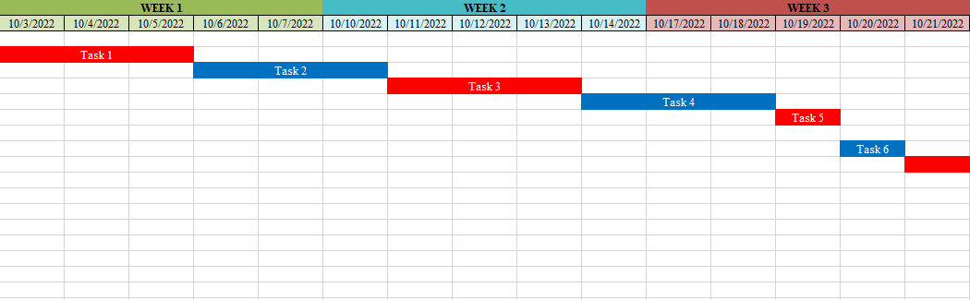

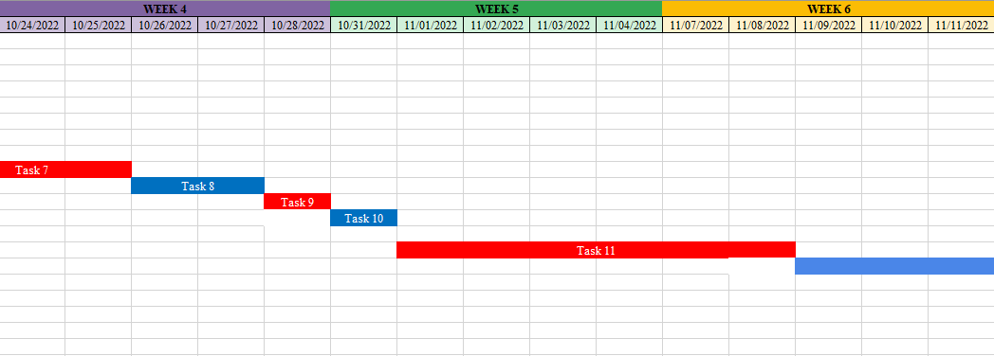

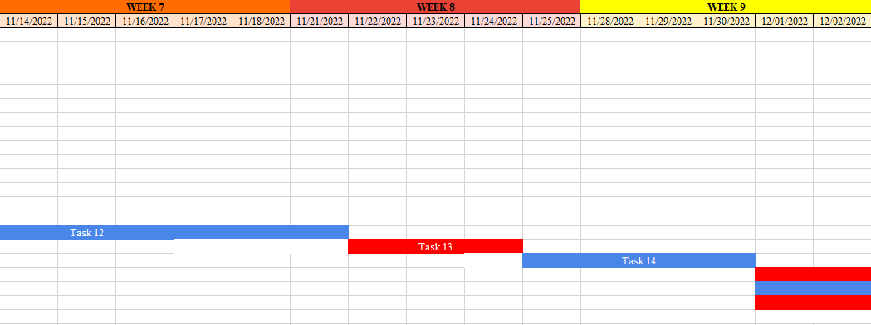

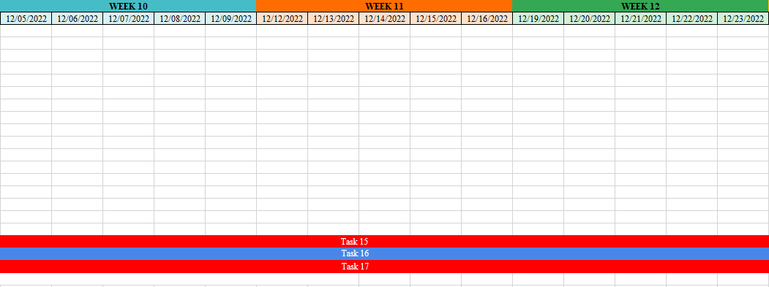  
  
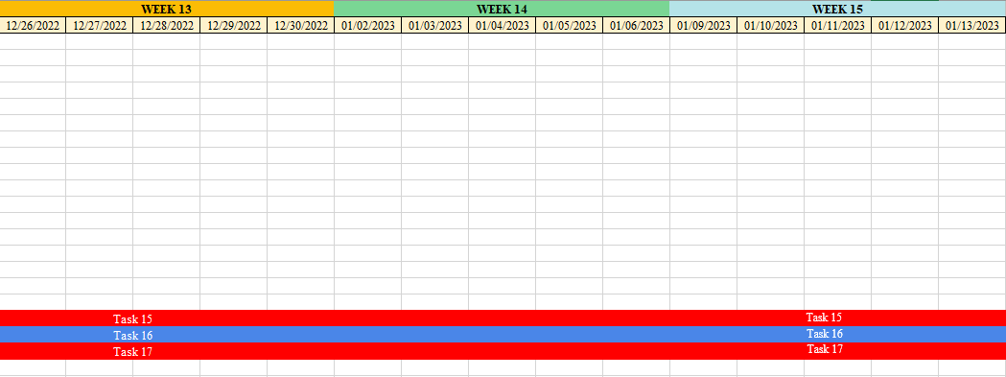  
  
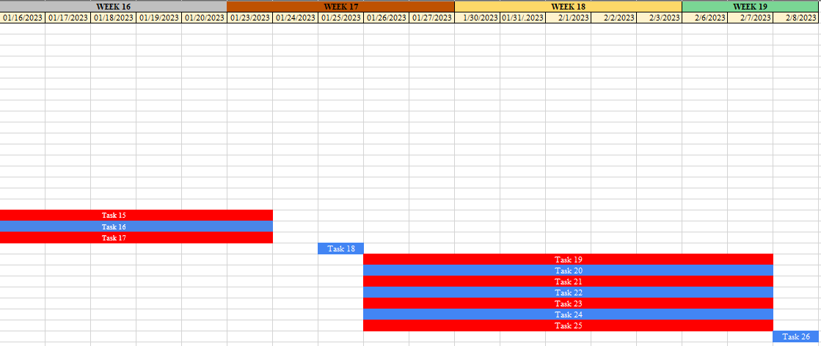

**APPENDIX C**

**LETTER TO RESPONDENTS**

MRS. MELITA L. LLONOR

Barangay Secretary

Dear Mrs. Llonor:

Greetings!

We, the fourth-year students at Technological University of the Philippines – Manila pursuing a degree in Bachelor of Engineering Technology major in Computer Engineering Technology, are currently enrolled in Project Development.

We are writing to humbly request a meeting with you, on July 22, 2022 to discuss our Project.

Thank you for your consideration and we hope you will be able to fulfill our request.

Respectfully yours,

The Researchers







Genikka Rose T. Bautista Christian James D. Punzal



Lionel M. Hernandez Bjorn P. Villarta

John Paul C. Andal Abegail Catalan

**APPENDIX E**

**LETTER TO MODIFY THE RESEARCH TITLE**

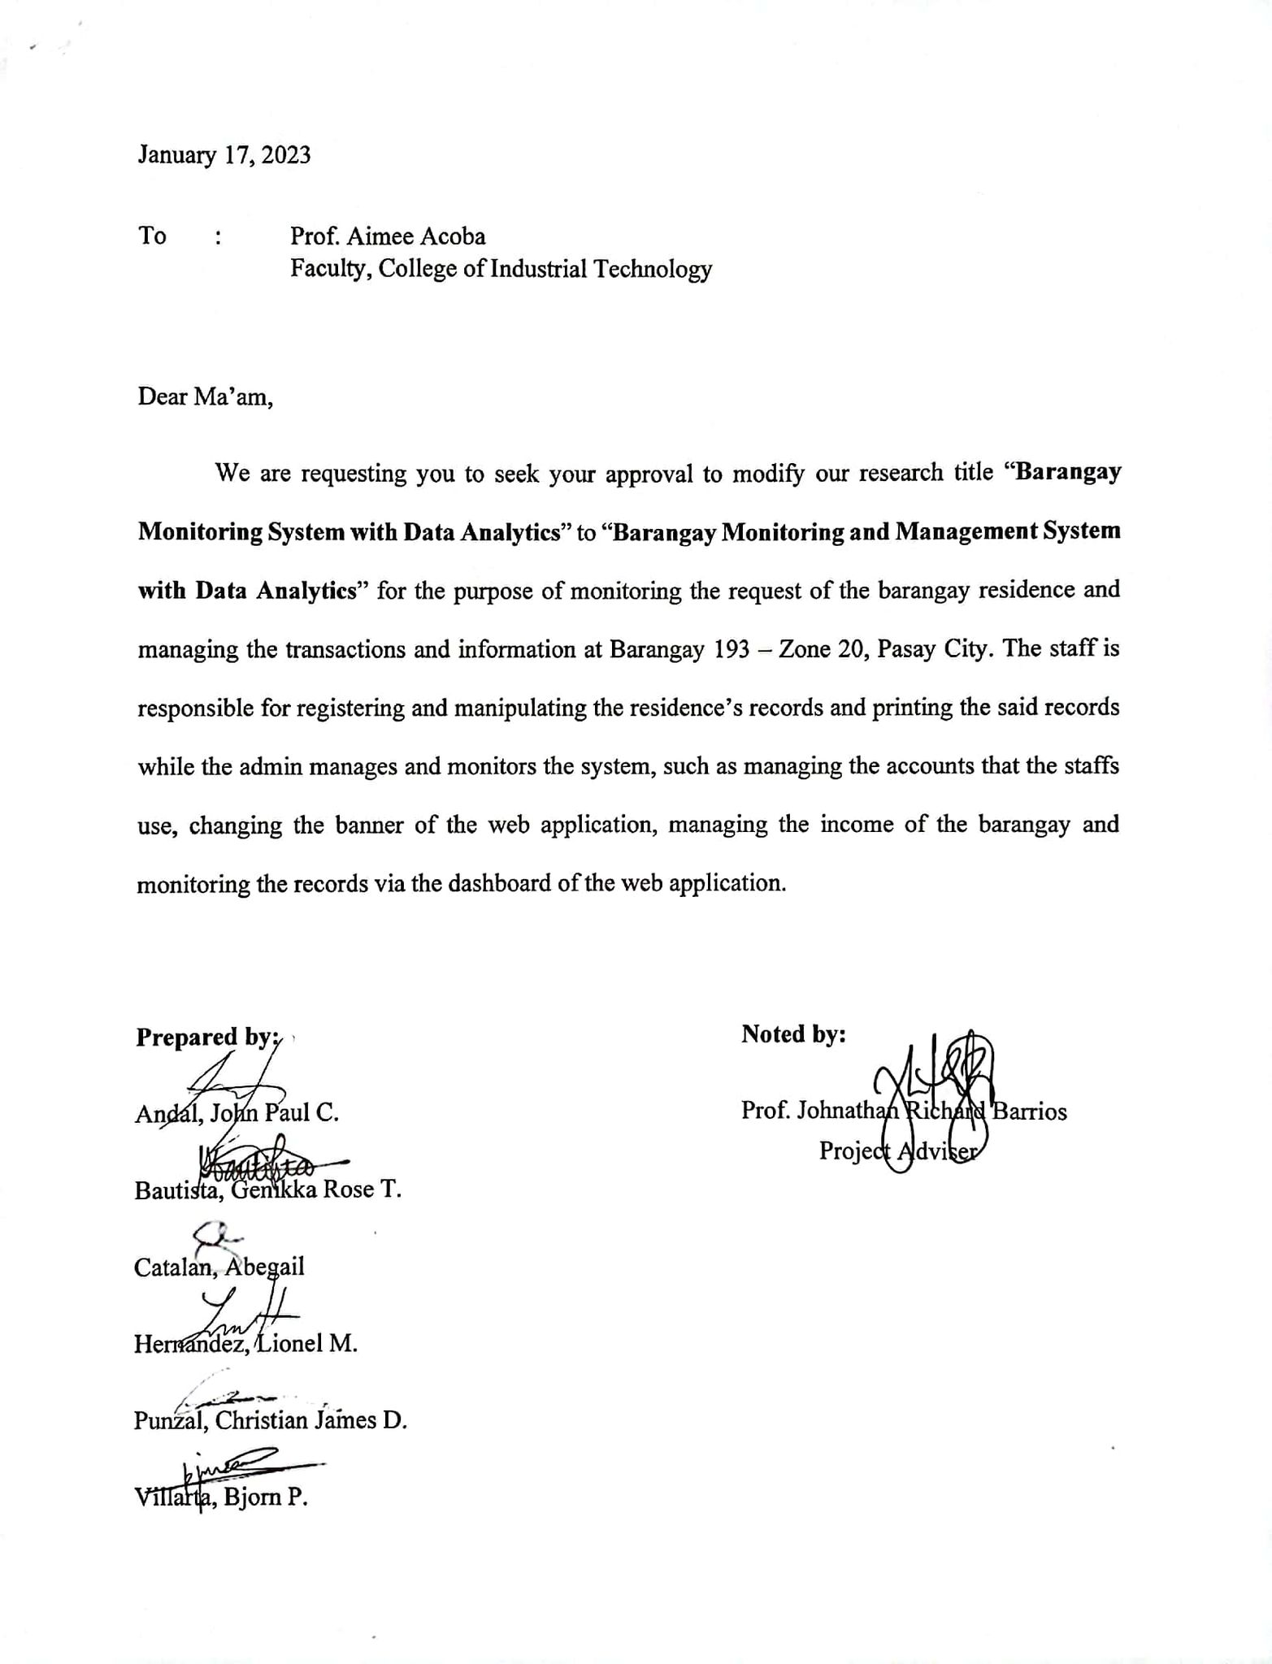

**APPENDIX F**

**LETTER OF CONSENT**



**APPENDIX G**

**PROFILE OF THE RESPONDENTS**

|  |  |  |  |
| --- | --- | --- | --- |
| **Respondent No.** | **Name** | **Designation** | **Dept./College/Office** |
| 1 | Michael F. Dawal | Barangay Chairman | Brgy 193 – Zone 20, Pasay City |
| 2 | Edgardo Juve D. Gamulo | Committee on Education and Culture & Employment Service | Brgy 193 – Zone 20, Pasay City |
| 3 | Jan Rey B. Arellano | Committee on Public Works and Infrastructure Development | Brgy 193 – Zone 20, Pasay City |
| 4 | Ernesto B. Balistoy | Committee on Peace and Order | Brgy 193 – Zone 20, Pasay City |
| 5 | Yolanda C. Chavez | Committee on Women and Children’s Desk Office | Brgy 193 – Zone 20, Pasay City |
| 6 | Santos T. Manaog | Committee on Rules and Procedures | Brgy 193 – Zone 20, Pasay City |
| 7 | Edwin S. Amolo | Committee on Appropriation Cooperatives | Brgy 193 – Zone 20, Pasay City |
| 8 | Rodrigo M. Del Mundo Jr. | Committee on Health and Sanitation | Brgy 193 – Zone 20, Pasay City |
| 9 | April Immaculate F. Buloron | Committee on Youth and Sports Development | Brgy 193 – Zone 20, Pasay City |
| 10 | Emilio Luis C. Gomez | Barangay Treasurer | Brgy 193 – Zone 20, Pasay City |
| 11 | Melita L. LLonor | Barangay Secretary | Brgy 193 – Zone 20, Pasay City |
| 12 | Gina C. Flores | Staff Clerk | Brgy 193 – Zone 20, Pasay City |
| 13 | Cashmere C. Vitancon | Deputized Collection Officer | Brgy 193 – Zone 20, Pasay City |
| 14 | Lizette S. Mones | Field Staff | Brgy 193 – Zone 20, Pasay City |
| 15 | Melissa Naduma | Clerk 2 | Brgy 193 – Zone 20, Pasay City |
| 16 | Patricia Abigail L. Llonor | Resident | Brgy 193 – Zone 20, Pasay City |
| 17 | Divina C. Sison | Resident | Brgy 193 – Zone 20, Pasay City |
| 18 | Henry B. Ferreras Jr. | Resident | Brgy 193 – Zone 20, Pasay City |

**APPENDIX H**

**TEST RESULTS**

**TEST CASE (1/50)**

|  |  |
| --- | --- |
| **Test Suite ID** | BMMS-01 |
| **Test Case ID** | BMMS-Admin-01 |
| **Test Case Summary** | To login in the web application as Admin |
| **Prerequisites** | None |
| **Test Procedure** | 1. Input Email 2. Input Password 3. Click Login Button |
| **Test Data** | 1. Email 2. Password |
| **Expected Result** | 1. Admin should be able to successfully login the registered account. 2. An error will be displayed if Admin uses wrong account credentials. |
| **Actual Result** | 1. The account has been successfully logged into by Admin. |
| **Status** | Pass |
| **Remarks** | The procedure testing and the button is functioning well in test 01. |
| **Created by** | GROUP 1 |
| **Date of Creation** | January 23, 2023 |
| **Executed by** | Melita L. Llonor |
| **Date of Execution** | January 25, 2023 |
| **Test Environment** | Acer Aspire 3 |

**TEST CASE (2/50)**

|  |  |
| --- | --- |
| **Test Suite ID** | BMMS-02 |
| **Test Case ID** | BMMS-Admin-02 |
| **Test Case Summary** | To reset forgot password. |
| **Prerequisites** | None |
| **Test Procedure** | 1. Click “Forgot Password” button 2. Input Email |
| **Test Data** | 1. Email |
| **Expected Result** | 1. Admin will receive verification code in their email. 2. If Admin enters the wrong account credentials, an error message will appear. |
| **Actual Result** | 1. Admin successfully reset the password. |
| **Status** | Pass |
| **Remarks** | The procedure testing and the button is functioning well in test 02. |
| **Created by** | GROUP 1 |
| **Date of Creation** | January 23, 2023 |
| **Executed by** | Melita L. Llonor |
| **Date of Execution** | January 25, 2023 |
| **Test Environment** | Dell Inspiron 3501 |

**TEST CASE (3/50)**

|  |  |
| --- | --- |
| **Test Suite ID** | BMMS-03 |
| **Test Case ID** | BMMS-Admin-03 |
| **Test Case Summary** | To view dashboard. |
| **Prerequisites** | None |
| **Test Procedure** | 1. Click “Dashboard” bar on the left side. |
| **Test Data** | 1. View dashboard |
| **Expected Result** | 1. Admin should view the dashboard containing data analytics of residents. |
| **Actual Result** | 1. Admin successfully viewed the dashboard. |
| **Status** | Pass |
| **Remarks** | The procedure testing and the button is functioning well in test 03. |
| **Created by** | GROUP 1 |
| **Date of Creation** | January 23, 2023 |
| **Executed by** | Melita L. Llonor |
| **Date of Execution** | January 25, 2023 |
| **Test Environment** | Dell Inspiron 3501 |

**TEST CASE (4/50)**

|  |  |
| --- | --- |
| **Test Suite ID** | BMMS-04 |
| **Test Case ID** | BMMS-Admin-04 |
| **Test Case Summary** | To create new barangay activity. |
| **Prerequisites** | None |
| **Test Procedure** | 1. Click the Dashboard 2. Click the “New Activity” button located under the pie graph 3. Input activity name and date 4. Click “Submit” button |
| **Test Data** | 1. Activity Name 2. Activity Date |
| **Expected Result** | 1. Admin should create new activity |
| **Actual Result** | 1. Admin successfully created new activity |
| **Status** | Pass |
| **Remarks** | The procedure testing and the button is functioning well in test 04. |
| **Created by** | GROUP 1 |
| **Date of Creation** | January 23, 2023 |
| **Executed by** | Melita L. Llonor |
| **Date of Execution** | January 25, 2023 |
| **Test Environment** | Dell Inspiron 3501 |

**TEST CASE (5/50)**

|  |  |
| --- | --- |
| **Test Suite ID** | BMMS-05 |
| **Test Case ID** | BMMS-Admin-05 |
| **Test Case Summary** | To edit barangay activity. |
| **Prerequisites** | None |
| **Test Procedure** | 1. Click the Dashboard 2. Click the “Edit” button 3. Edit activity name or date 4. Click “Submit” button |
| **Test Data** | 1. Activity Name 2. Activity Date |
| **Expected Result** | 1. Admin should edit activity |
| **Actual Result** | 1. Admin successfully edited activity |
| **Status** | Pass |
| **Remarks** | The procedure testing and the button is functioning well in test 05. |
| **Created by** | GROUP 1 |
| **Date of Creation** | January 23, 2023 |
| **Executed by** | Melita L. Llonor |
| **Date of Execution** | January 25, 2023 |
| **Test Environment** | Dell Inspiron 3501 |

**TEST CASE (6/50)**

|  |  |
| --- | --- |
| **Test Suite ID** | BMMS-06 |
| **Test Case ID** | BMMS-Admin-06 |
| **Test Case Summary** | To delete barangay activity. |
| **Prerequisites** | None |
| **Test Procedure** | 1. Click the Dashboard 2. Click the “Delete” button |
| **Test Data** | 1. Activity Name 2. Activity Date |
| **Expected Result** | 1. Admin should edit activity |
| **Actual Result** | 1. Admin successfully edited activity |
| **Status** | Pass |
| **Remarks** | The procedure testing and the button is functioning well in test 06. |
| **Created by** | GROUP 1 |
| **Date of Creation** | January 23, 2023 |
| **Executed by** | Melita L. Llonor |
| **Date of Execution** | January 25, 2023 |
| **Test Environment** | Dell Inspiron 3501 |

**TEST CASE (7/50)**

|  |  |
| --- | --- |
| **Test Suite ID** | BMMS-07 |
| **Test Case ID** | BMMS-Admin-07 |
| **Test Case Summary** | To logout the web application account of the Admin |
| **Prerequisites** | None |
| **Test Procedure** | 1. Click the “Logout” button |
| **Test Data** | Logging out the account |
| **Expected Result** | 1. Admin should be able to logout the account |
| **Actual Result** | 1. Admin successfully logged out the account |
| **Status** | Pass |
| **Remarks** | The procedure testing and the button is functioning well in test 07. |
| **Created by** | GROUP 1 |
| **Date of Creation** | January 23, 2023 |
| **Executed by** | Melita L. Llonor |
| **Date of Execution** | January 25, 2023 |
| **Test Environment** | Dell Inspiron 3501 |

**TEST CASE (8/50)**

|  |  |
| --- | --- |
| **Test Suite ID** | BMMS-08 |
| **Test Case ID** | BMMS-Admin-08 |
| **Test Case Summary** | To view the list of residents |
| **Prerequisites** | None |
| **Test Procedure** | 1. Click the “Residence” tab |
| **Test Data** | 1. Viewing data |
| **Expected Result** | 1. Admin should be able to see the list of residents |
| **Actual Result** | 1. Admin successfully viewed the list of residents |
| **Status** | Pass |
| **Remarks** | The procedure testing and the button is functioning well in test 08. |
| **Created by** | GROUP 1 |
| **Date of Creation** | January 23, 2023 |
| **Executed by** | Melita L. Llonor |
| **Date of Execution** | January 25, 2023 |
| **Test Environment** | Dell Inspiron 3501 |

**TEST CASE (9/50)**

|  |  |
| --- | --- |
| **Test Suite ID** | BMMS-09 |
| **Test Case ID** | BMMS-Admin-09 |
| **Test Case Summary** | To create new residents’ data. |
| **Prerequisites** | None |
| **Test Procedure** | 1. Click Residence bar on the left side 2. Click “New Resident” button 3. Input Name 4. Input Date of Birth 5. Input Place of Birth 6. Select Sex 7. Select Civil Status 8. Select Citizenship 9. Input Profession or Occupation 10. Select Religion 11. Input Contact Number 12. Input Address 13. Select Family Indicator 14. Input Family Head Name 15. Input Family Role 16. Select Sector 17. Select Residence Status 18. Select Voter Status 19. Select Barangay ID Status 20. Select QR Code Status 21. Input Month of Stay 22. Input Years of Stay 23. Upload Resident Picture 24. Upload Digital Signature 25. Upload Scanned Personal Document (Optional) 26. Click Submit Button |
| **Test Data** | 1. First Name 2. Middle Name (Optional) 3. Last Name 4. Extension or Suffix (Optional) 5. Date of Birth 6. Age 7. Place of Birth 8. Sex 9. Civil Status 10. Citizenship 11. Profession or Occupation 12. Religion 13. Contact Number 14. House Number 15. Street Name 16. Sitio or Purok 17. Zone 18. Barangay 19. Municipality 20. Province 21. Region 22. Family Indicator 23. Family Head Name 24. Family Role 25. Sector 26. Residence Status 27. Voter Status 28. Barangay ID Status 29. QR Status 30. Months of Stay 31. Years of Stay 32. Resident Picture 33. Digital Signature 34. Scanned Personal Documents (Optional) |
| **Expected Result** | 1. Admin should be able to create new resident information. |
| **Actual Result** | 1. Admin successfully added new resident information. |
| **Status** | Pass |
| **Remarks** | The procedure testing and the button is functioning well in test 09. |
| **Created by** | GROUP 1 |
| **Date of Creation** | January 23, 2023 |
| **Executed by** | Melita L. Llonor |
| **Date of Execution** | January 25, 2023 |
| **Test Environment** | Dell Inspiron 3501 |

**TEST CASE (10/50)**

|  |  |
| --- | --- |
| **Test Suite ID** | BMMS-10 |
| **Test Case ID** | BMMS-Admin-10 |
| **Test Case Summary** | To view the residents data |
| **Prerequisites** | None |
| **Test Procedure** | 1. Click the “Residence” tab 2. Click the view icon button |
| **Test Data** | 1. Viewing data |
| **Expected Result** | 1. Admin should be able to see the data of residents |
| **Actual Result** | 1. Admin successfully viewed the data of residents |
| **Status** | Pass |
| **Remarks** | The procedure testing and the button is functioning well in test 10. |
| **Created by** | GROUP 1 |
| **Date of Creation** | January 23, 2023 |
| **Executed by** | Melita L. Llonor |
| **Date of Execution** | January 25, 2023 |
| **Test Environment** | Dell Inspiron 3501 |

**TEST CASE (11/50)**

|  |  |
| --- | --- |
| **Test Suite ID** | BMMS-11 |
| **Test Case ID** | BMMS-Admin-11 |
| **Test Case Summary** | To edit residents’ data. |
| **Prerequisites** | None |
| **Test Procedure** | 1. Click Residence bar on the left side 2. Click pencil icon button 3. Update information needed 4. Click “Update” button after some changes |
| **Test Data** | 1. Updating information |
| **Expected Result** | 1. Admin should be able to update resident information. |
| **Actual Result** | 1. Admin successfully updated resident information. |
| **Status** | Pass |
| **Remarks** | The procedure testing and the button is functioning well in test 11. |
| **Created by** | GROUP 1 |
| **Date of Creation** | January 23, 2023 |
| **Executed by** | Melita L. Llonor |
| **Date of Execution** | January 25, 2023 |
| **Test Environment** | Dell Inspiron 3501 |

**TEST CASE (12/50)**

|  |  |
| --- | --- |
| **Test Suite ID** | BMMS-12 |
| **Test Case ID** | BMMS-Admin-12 |
| **Test Case Summary** | To delete resident data |
| **Prerequisites** | None |
| **Test Procedure** | 1. Click Residence bar on the left side 2. Click the trash can icon 3. Click “Delete” button |
| **Test Data** | 1. Deleting data |
| **Expected Result** | 1. Admin should be able delete a resident data |
| **Actual Result** | 1. Admin successfully deleted a resident data |
| **Status** | Pass |
| **Remarks** | The procedure testing and the button is functioning well in test 12. |
| **Created by** | GROUP 1 |
| **Date of Creation** | January 23, 2023 |
| **Executed by** | Melita L. Llonor |
| **Date of Execution** | January 25, 2023 |
| **Test Environment** | Dell Inspiron 3501 |

**TEST CASE (13/50)**

|  |  |
| --- | --- |
| **Test Suite ID** | BMMS-13 |
| **Test Case ID** | BMMS-Admin-13 |
| **Test Case Summary** | To view resident’s personal document |
| **Prerequisites** | None |
| **Test Procedure** | 1. Click Residence bar on the left side 2. Click the paper icon |
| **Test Data** | 1. Viewing data |
| **Expected Result** | 1. Admin should be able to view the resident’s personal document |
| **Actual Result** | 1. Admin successfully viewed resident’s personal document |
| **Status** | Pass |
| **Remarks** | The procedure testing and the button is functioning well in test 13. |
| **Created by** | GROUP 1 |
| **Date of Creation** | January 23, 2023 |
| **Executed by** | Melita L. Llonor |
| **Date of Execution** | January 25, 2023 |
| **Test Environment** | Dell Inspiron 3501 |

**TEST CASE (14/50)**

|  |  |
| --- | --- |
| **Test Suite ID** | BMMS-14 |
| **Test Case ID** | BMMS-Admin-14 |
| **Test Case Summary** | To view resident’s QR Code |
| **Prerequisites** | None |
| **Test Procedure** | 1. Click Residence bar on the left side 2. Click the QR code icon |
| **Test Data** | 1. Viewing QR code |
| **Expected Result** | 1. Admin should be able to view the resident’s QR Code |
| **Actual Result** | 1. Admin successfully viewed resident’s QR code |
| **Status** | Pass |
| **Remarks** | The procedure testing and the button is functioning well in test 14. |
| **Created by** | GROUP 1 |
| **Date of Creation** | January 23, 2023 |
| **Executed by** | Melita L. Llonor |
| **Date of Execution** | January 25, 2023 |
| **Test Environment** | Dell Inspiron 3501 |

**TEST CASE (15/50)**

|  |  |
| --- | --- |
| **Test Suite ID** | BMMS-15 |
| **Test Case ID** | BMMS-Admin-15 |
| **Test Case Summary** | To sort resident’s data |
| **Prerequisites** | None |
| **Test Procedure** | 1. Click Residence bar on the left side 2. Choose what type need to sort 3. Click the “Filter” button |
| **Test Data** | 1. Sorting information |
| **Expected Result** | 1. Admin should be able to sort the resident’s data |
| **Actual Result** | 1. Admin successfully sorted resident’s data |
| **Status** | Pass |
| **Remarks** | The procedure testing and the button is functioning well in test 15. |
| **Created by** | GROUP 1 |
| **Date of Creation** | January 23, 2023 |
| **Executed by** | Melita L. Llonor |
| **Date of Execution** | January 25, 2023 |
| **Test Environment** | Dell Inspiron 3501 |

**TEST CASE (16/50)**

|  |  |
| --- | --- |
| **Test Suite ID** | BMMS-16 |
| **Test Case ID** | BMMS-Admin-16 |
| **Test Case Summary** | To export excel file of resident’s data |
| **Prerequisites** | None |
| **Test Procedure** | 1. Click Residence bar on the left side 2. Click the Export button |
| **Test Data** | 1. Exporting excel file |
| **Expected Result** | 1. Admin should be able to export excel file of resident’s data |
| **Actual Result** | 1. Admin successfully exported excel file of resident’s data |
| **Status** | Pass |
| **Remarks** | The procedure testing and the button is functioning well in test 16. |
| **Created by** | GROUP 1 |
| **Date of Creation** | January 23, 2023 |
| **Executed by** | Melita L. Llonor |
| **Date of Execution** | January 25, 2023 |
| **Test Environment** | Dell Inspiron 3501 |

**TEST CASE (17/50)**

|  |  |
| --- | --- |
| **Test Suite ID** | BMMS-17 |
| **Test Case ID** | BMMS-Admin-17 |
| **Test Case Summary** | To create barangay printable certificate. |
| **Prerequisites** | None |
| **Test Procedure** | 1. Click Document tab 2. Fill in the required fields 3. Click Proceed |
| **Test Data** | 1. Resident Name 2. Purpose 3. Amount |
| **Expected Result** | 1. Admin will create a printable document requested by residents |
| **Actual Result** | 1. Admin successfully created printable documents. |
| **Status** | Pass |
| **Remarks** | The procedure testing and the button is functioning well in test 17. |
| **Created by** | GROUP 1 |
| **Date of Creation** | January 23, 2023 |
| **Executed by** | Melita L. Llonor |
| **Date of Execution** | January 25, 2023 |
| **Test Environment** | Dell Inspiron 3501 |

**TEST CASE (18/50)**

|  |  |
| --- | --- |
| **Test Suite ID** | BMMS-18 |
| **Test Case ID** | BMMS-Admin-18 |
| **Test Case Summary** | To view barangay income report |
| **Prerequisites** | None |
| **Test Procedure** | 1. Click barangay income tab 2. Click the income report tab |
| **Test Data** | 1. Viewing income report |
| **Expected Result** | 1. Admin should be able to view the income report |
| **Actual Result** | 1. Admin successfully viewed the income report |
| **Status** | Pass |
| **Remarks** | The procedure testing and the button is functioning well in test 18. |
| **Created by** | GROUP 1 |
| **Date of Creation** | January 23, 2023 |
| **Executed by** | Melita L. Llonor |
| **Date of Execution** | January 25, 2023 |
| **Test Environment** | Dell Inspiron 3501 |

**TEST CASE (19/50)**

|  |  |
| --- | --- |
| **Test Suite ID** | BMMS-19 |
| **Test Case ID** | BMMS-Admin-19 |
| **Test Case Summary** | To view the list of barangay income |
| **Prerequisites** | None |
| **Test Procedure** | 1. Click barangay income tab 2. Click the document income tab |
| **Test Data** | 1. Viewing list of document income |
| **Expected Result** | 1. Admin should be able to view the list of document income |
| **Actual Result** | 1. Admin successfully viewed the list of document income |
| **Status** | Pass |
| **Remarks** | The procedure testing and the button is functioning well in test 19. |
| **Created by** | GROUP 1 |
| **Date of Creation** | January 23, 2023 |
| **Executed by** | Melita L. Llonor |
| **Date of Execution** | January 25, 2023 |
| **Test Environment** | Dell Inspiron 3501 |

**TEST CASE (20/50)**

|  |  |
| --- | --- |
| **Test Suite ID** | BMMS-20 |
| **Test Case ID** | BMMS-Admin-20 |
| **Test Case Summary** | To sort the list of barangay income |
| **Prerequisites** | None |
| **Test Procedure** | 1. Click barangay income tab 2. Click the document income tab 3. Choose the type of income that need to sort 4. Click the “Filter” button |
| **Test Data** | 1. Sorting document income |
| **Expected Result** | 1. Admin should be able to sort the list of document income |
| **Actual Result** | 1. Admin successfully sorted the list of document income |
| **Status** | Pass |
| **Remarks** | The procedure testing and the button is functioning well in test 20. |
| **Created by** | GROUP 1 |
| **Date of Creation** | January 23, 2023 |
| **Executed by** | Melita L. Llonor |
| **Date of Execution** | January 25, 2023 |
| **Test Environment** | Dell Inspiron 3501 |

**TEST CASE (21/50)**

|  |  |
| --- | --- |
| **Test Suite ID** | BMMS-21 |
| **Test Case ID** | BMMS-Admin-21 |
| **Test Case Summary** | To export excel file of barangay income |
| **Prerequisites** | None |
| **Test Procedure** | 1. Click barangay income tab 2. Click the document income tab 3. Click the “Export” button |
| **Test Data** | 1. Exporting document income |
| **Expected Result** | 1. Admin should be able to export file of document income |
| **Actual Result** | 1. Admin successfully exported file of document income |
| **Status** | Pass |
| **Remarks** | The procedure testing and the button is functioning well in test 21. |
| **Created by** | GROUP 1 |
| **Date of Creation** | January 23, 2023 |
| **Executed by** | Melita L. Llonor |
| **Date of Execution** | January 25, 2023 |
| **Test Environment** | Dell Inspiron 3501 |

**TEST CASE (22/50)**

|  |  |
| --- | --- |
| **Test Suite ID** | BMMS-22 |
| **Test Case ID** | BMMS-Admin-22 |
| **Test Case Summary** | To add new barangay income |
| **Prerequisites** | None |
| **Test Procedure** | 1. Click “Brgy Income” tab on the left side 2. Click the New Income tab 3. Input Payment Type 4. Input Description (Optional) 5. Input Amount |
| **Test Data** | 1. Payment Type 2. Description (Optional) 3. Amount |
| **Expected Result** | 1. Admin should be able create a new barangay income |
| **Actual Result** | 1. Admin successfully created new barangay income report |
| **Status** | Pass |
| **Remarks** | The procedure testing and the button is functioning well in test 22. |
| **Created by** | GROUP 1 |
| **Date of Creation** | January 23, 2023 |
| **Executed by** | Melita L. Llonor |
| **Date of Execution** | January 25, 2023 |
| **Test Environment** | Dell Inspiron 3501 |

**TEST CASE (23/50)**

|  |  |
| --- | --- |
| **Test Suite ID** | BMMS-23 |
| **Test Case ID** | BMMS-Admin-23 |
| **Test Case Summary** | To view barangay officials |
| **Prerequisites** | None |
| **Test Procedure** | 1. Click “Brgy. Profiles” tab on the left side |
| **Test Data** | 1. Viewing barangay officials |
| **Expected Result** | 1. Admin should be able to view the barangay officials |
| **Actual Result** | 1. Admin successfully viewed the barangay officials |
| **Status** | Pass |
| **Remarks** | The procedure testing and the button is functioning well in test 23. |
| **Created by** | GROUP 1 |
| **Date of Creation** | January 23, 2023 |
| **Executed by** | Melita L. Llonor |
| **Date of Execution** | January 25, 2023 |
| **Test Environment** | Dell Inspiron 3501 |

**TEST CASE (24/50)**

|  |  |
| --- | --- |
| **Test Suite ID** | BMMS-24 |
| **Test Case ID** | BMMS-Admin-24 |
| **Test Case Summary** | To create barangay officials |
| **Prerequisites** | None |
| **Test Procedure** | 1. Click “Brgy. Profiles” tab on the left side 2. Click “New Official” button 3. Fill out the required fields 4. Click Submit button |
| **Test Data** | 1. Position 2. First Name 3. Middle Name 4. Last Name 5. Suffix Name (optional) 6. Description 7. Upload Official’s Picture |
| **Expected Result** | 1. Admin should be able to add new barangay officials |
| **Actual Result** | 1. Admin successfully added new barangay officials |
| **Status** | Pass |
| **Remarks** | The procedure testing and the button is functioning well in test 24. |
| **Created by** | GROUP 1 |
| **Date of Creation** | January 23, 2023 |
| **Executed by** | Melita L. Llonor |
| **Date of Execution** | January 25, 2023 |
| **Test Environment** | Dell Inspiron 3501 |

**TEST CASE (25/50)**

|  |  |
| --- | --- |
| **Test Suite ID** | BMMS-25 |
| **Test Case ID** | BMMS-Admin-25 |
| **Test Case Summary** | To edit the barangay officials |
| **Prerequisites** | None |
| **Test Procedure** | 1. Click “Brgy. Profiles” tab on the left side 2. Click “Edit” button 3. Edit the information needed 4. Click Update button |
| **Test Data** | 1. Updating infomation |
| **Expected Result** | 1. Admin should be able to update the barangay officials. |
| **Actual Result** | 1. Admin successfully updated the barangay officials. |
| **Status** | Pass |
| **Remarks** | The procedure testing and the button is functioning well in test 25. |
| **Created by** | GROUP 1 |
| **Date of Creation** | January 23, 2023 |
| **Executed by** | Melita L. Llonor |
| **Date of Execution** | January 25, 2023 |
| **Test Environment** | Dell Inspiron 3501 |

**TEST CASE (26/50)**

|  |  |
| --- | --- |
| **Test Suite ID** | BMMS-26 |
| **Test Case ID** | BMMS-Admin-26 |
| **Test Case Summary** | To delete the barangay officials |
| **Prerequisites** | None |
| **Test Procedure** | 1. Click “Brgy. Profiles” tab on the left side 2. Click “Delete” button |
| **Test Data** | 1. Deleting information |
| **Expected Result** | 1. Admin should be able to delete the barangay officials. |
| **Actual Result** | 1. Admin successfully deleted the barangay officials. |
| **Status** | Pass |
| **Remarks** | The procedure testing and the button is functioning well in test 26. |
| **Created by** | GROUP 1 |
| **Date of Creation** | January 23, 2023 |
| **Executed by** | Melita L. Llonor |
| **Date of Execution** | January 25, 2023 |
| **Test Environment** | Dell Inspiron 3501 |

**TEST CASE (27/50)**

|  |  |
| --- | --- |
| **Test Suite ID** | BMMS-27 |
| **Test Case ID** | BMMS-Admin-27 |
| **Test Case Summary** | To export excel file of the barangay officials |
| **Prerequisites** | None |
| **Test Procedure** | 1. Click “Brgy. Profiles” tab on the left side 2. Click “Export” button |
| **Test Data** | 1. Exporting information |
| **Expected Result** | 1. Admin should be able to export the barangay officials. |
| **Actual Result** | 1. Admin successfully exported the barangay officials. |
| **Status** | Pass |
| **Remarks** | The procedure testing and the button is functioning well in test 27. |
| **Created by** | GROUP 1 |
| **Date of Creation** | January 23, 2023 |
| **Executed by** | Melita L. Llonor |
| **Date of Execution** | January 25, 2023 |
| **Test Environment** | Dell Inspiron 3501 |

**TEST CASE (28/50)**

|  |  |
| --- | --- |
| **Test Suite ID** | BMMS-28 |
| **Test Case ID** | BMMS-Admin-28 |
| **Test Case Summary** | To export excel file of the barangay officials |
| **Prerequisites** | None |
| **Test Procedure** | 1. Click “Brgy. Profiles” tab on the left side 2. Click “Export” button |
| **Test Data** | 1. Exporting information |
| **Expected Result** | 1. Admin should be able to export the barangay officials. |
| **Actual Result** | 1. Admin successfully exported the barangay officials. |
| **Status** | Pass |
| **Remarks** | The procedure testing and the button is functioning well in test 28. |
| **Created by** | GROUP 1 |
| **Date of Creation** | January 23, 2023 |
| **Executed by** | Melita L. Llonor |
| **Date of Execution** | January 25, 2023 |
| **Test Environment** | Dell Inspiron 3501 |

**TEST CASE (29/50)**

|  |  |
| --- | --- |
| **Test Suite ID** | BMMS-29 |
| **Test Case ID** | BMMS-Admin-29 |
| **Test Case Summary** | To create new user account |
| **Prerequisites** | None |
| **Test Procedure** | 1. Click “Account” tab on the left side 2. Click “New User” button |
| **Test Data** | 1. User Type 2. Username 3. First Name 4. Middle Name 5. Last Name 6. Suffix Name (optional) 7. Contact Number 8. Email Address 9. Password 10. Confirm Password |
| **Expected Result** | 1. Admin should be able create new user account |
| **Actual Result** | 1. Admin successfully created new user account |
| **Status** | Pass |
| **Remarks** | The procedure testing and the button is functioning well in test 29. |
| **Created by** | GROUP 1 |
| **Date of Creation** | January 23, 2023 |
| **Executed by** | Melita L. Llonor |
| **Date of Execution** | January 25, 2023 |
| **Test Environment** | Dell Inspiron 3501 |

**TEST CASE (30/50)**

|  |  |
| --- | --- |
| **Test Suite ID** | BMMS-30 |
| **Test Case ID** | BMMS-Admin-30 |
| **Test Case Summary** | To edit user account |
| **Prerequisites** | None |
| **Test Procedure** | 1. Click “Account” tab on the left side 2. Click “Edit” button |
| **Test Data** | 1. Updating Account |
| **Expected Result** | 1. Admin should be able update user account |
| **Actual Result** | 1. Admin successfully updated user account |
| **Status** | Pass |
| **Remarks** | The procedure testing and the button is functioning well in test 30. |
| **Created by** | GROUP 1 |
| **Date of Creation** | January 23, 2023 |
| **Executed by** | Melita L. Llonor |
| **Date of Execution** | January 25, 2023 |
| **Test Environment** | Dell Inspiron 3501 |

**TEST CASE (31/50)**

|  |  |
| --- | --- |
| **Test Suite ID** | BMMS-31 |
| **Test Case ID** | BMMS-Admin-31 |
| **Test Case Summary** | To change account password |
| **Prerequisites** | None |
| **Test Procedure** | 1. Click “Account” tab on the left side 2. Click “Security” button 3. Input the old password 4. Input the new password 5. Confirm the new password 6. Click “Update” button |
| **Test Data** | 1. Changing password |
| **Expected Result** | 1. Admin should be able change account password |
| **Actual Result** | 1. Admin successfully changed account password |
| **Status** | Pass |
| **Remarks** | The procedure testing and the button is functioning well in test 31. |
| **Created by** | GROUP 1 |
| **Date of Creation** | January 23, 2023 |
| **Executed by** | Melita L. Llonor |
| **Date of Execution** | January 25, 2023 |
| **Test Environment** | Dell Inspiron 3501 |

**TEST CASE (32/50)**

|  |  |
| --- | --- |
| **Test Suite ID** | BMMS-32 |
| **Test Case ID** | BMMS-Admin-32 |
| **Test Case Summary** | To delete staff account |
| **Prerequisites** | None |
| **Test Procedure** | 1. Click “Account” tab on the left side 2. Click “Delete” button |
| **Test Data** | 1. Deleting account |
| **Expected Result** | 1. Admin should be able delete staff account |
| **Actual Result** | 1. Admin successfully deleted staff account |
| **Status** | Pass |
| **Remarks** | The procedure testing and the button is functioning well in test 32. |
| **Created by** | GROUP 1 |
| **Date of Creation** | January 23, 2023 |
| **Executed by** | Melita L. Llonor |
| **Date of Execution** | January 25, 2023 |
| **Test Environment** | Dell Inspiron 3501 |

**TEST CASE (33/50)**

|  |  |
| --- | --- |
| **Test Suite ID** | BMMS-33 |
| **Test Case ID** | BMMS-Admin-33 |
| **Test Case Summary** | To search name of user account |
| **Prerequisites** | None |
| **Test Procedure** | 1. Click “Account” tab on the left side 2. Input the name of user in search bar |
| **Test Data** | 1. Searching name of user account |
| **Expected Result** | 1. Admin should be able to search user account |
| **Actual Result** | 1. Admin successfully searched user account |
| **Status** | Pass |
| **Remarks** | The procedure testing and the button is functioning well in test 33. |
| **Created by** | GROUP 1 |
| **Date of Creation** | January 23, 2023 |
| **Executed by** | Melita L. Llonor |
| **Date of Execution** | January 25, 2023 |
| **Test Environment** | Dell Inspiron 3501 |

**TEST CASE (34/50)**

|  |  |
| --- | --- |
| **Test Suite ID** | BMMS-34 |
| **Test Case ID** | BMMS-Admin-34 |
| **Test Case Summary** | To upload new login banner |
| **Prerequisites** | None |
| **Test Procedure** | 1. Click the Customize tab 2. Click “New Customization” button 3. Browse 500 kb image to be upload 4. Click “Submit” button |
| **Test Data** | 1. Uploading login banner |
| **Expected Result** | 1. Admin should be able to upload new login banner |
| **Actual Result** | 1. Admin successfully uploaded new login banner |
| **Status** | Pass |
| **Remarks** | The procedure testing and the button is functioning well in test 34. |
| **Created by** | GROUP 1 |
| **Date of Creation** | January 23, 2023 |
| **Executed by** | Melita L. Llonor |
| **Date of Execution** | January 25, 2023 |
| **Test Environment** | Dell Inspiron 3501 |

**TEST CASE (35/50)**

|  |  |
| --- | --- |
| **Test Suite ID** | BMMS-35 |
| **Test Case ID** | BMMS-Admin-35 |
| **Test Case Summary** | To change login banner |
| **Prerequisites** | None |
| **Test Procedure** | 1. Click the Customize tab 2. Click “Set Active” button 3. Click “Update” button |
| **Test Data** | 1. Changing login banner |
| **Expected Result** | 1. Admin should be able to change login banner |
| **Actual Result** | 1. Admin successfully changed login banner |
| **Status** | Pass |
| **Remarks** | The procedure testing and the button is functioning well in test 35. |
| **Created by** | GROUP 1 |
| **Date of Creation** | January 23, 2023 |
| **Executed by** | Melita L. Llonor |
| **Date of Execution** | January 25, 2023 |
| **Test Environment** | Dell Inspiron 3501 |

**TEST CASE (36/50)**

|  |  |
| --- | --- |
| **Test Suite ID** | BMMS-36 |
| **Test Case ID** | BMMS-Staff-36 |
| **Test Case Summary** | To login in the web application as Staff |
| **Prerequisites** | None |
| **Test Procedure** | 1. Input Email 2. Input Password 3. Click Login Button |
| **Test Data** | 1. Email 2. Password |
| **Expected Result** | 1. Staff should be able to successfully login the registered account. 2. An error will be displayed if Staff uses wrong account credentials. |
| **Actual Result** | 1. The account has been successfully logged into by Staff. |
| **Status** | Pass |
| **Remarks** | The procedure testing and the button is functioning well in test 36. |
| **Created by** | GROUP 1 |
| **Date of Creation** | January 23, 2023 |
| **Executed by** | Melita L. Llonor |
| **Date of Execution** | January 25, 2023 |
| **Test Environment** | Acer Aspire 3 |

**TEST CASE (37/50)**

|  |  |
| --- | --- |
| **Test Suite ID** | BMMS-37 |
| **Test Case ID** | BMMS-Staff-37 |
| **Test Case Summary** | To reset forgot password. |
| **Prerequisites** | None |
| **Test Procedure** | 1. Click “Forgot Password” button 2. Input Email |
| **Test Data** | 1. Email |
| **Expected Result** | 1. Staff will receive verification code in their email. 2. If Admin enters the wrong account credentials, an error message will appear. |
| **Actual Result** | 1. Staff successfully reset the password. |
| **Status** | Pass |
| **Remarks** | The procedure testing and the button is functioning well in test 37. |
| **Created by** | GROUP 1 |
| **Date of Creation** | January 23, 2023 |
| **Executed by** | Gina C. Flores |
| **Date of Execution** | January 25, 2023 |
| **Test Environment** | Acer Aspire 3 |

**TEST CASE (38/50)**

|  |  |
| --- | --- |
| **Test Suite ID** | BMMS-38 |
| **Test Case ID** | BMMS-Staff-38 |
| **Test Case Summary** | To view the list of residents |
| **Prerequisites** | None |
| **Test Procedure** | 1. Click the “Residence” tab |
| **Test Data** | 1. Viewing data |
| **Expected Result** | 1. Admin should be able to see the list of residents |
| **Actual Result** | 1. Admin successfully viewed the list of residents |
| **Status** | Pass |
| **Remarks** | The procedure testing and the button is functioning well in test 38. |
| **Created by** | GROUP 1 |
| **Date of Creation** | January 23, 2023 |
| **Executed by** | Gina C. Flores |
| **Date of Execution** | January 25, 2023 |
| **Test Environment** | Acer Aspire 3 |

**TEST CASE (39/50)**

|  |  |
| --- | --- |
| **Test Suite ID** | BMMS-39 |
| **Test Case ID** | BMMS-Staff-39 |
| **Test Case Summary** | To create new residents’ data. |
| **Prerequisites** | None |
| **Test Procedure** | 1. Click Residence bar on the left side 2. Click “New Resident” button 3. Input Name 4. Input Date of Birth 5. Input Place of Birth 6. Select Sex 7. Select Civil Status 8. Select Citizenship 9. Input Profession or Occupation 10. Select Religion 11. Input Contact Number 12. Input Address 13. Select Family Indicator 14. Input Family Head Name 15. Input Family Role 16. Select Sector 17. Select Residence Status 18. Select Voter Status 19. Select Barangay ID Status 20. Select QR Code Status 21. Input Month of Stay 22. Input Years of Stay 23. Upload Resident Picture 24. Upload Digital Signature 25. Upload Scanned Personal Document (Optional) 26. Click Submit Button |
| **Test Data** | 1. First Name 2. Middle Name (Optional) 3. Last Name 4. Extension or Suffix (Optional) 5. Date of Birth 6. Age 7. Place of Birth 8. Sex 9. Civil Status 10. Citizenship 11. Profession or Occupation 12. Religion 13. Contact Number 14. House Number 15. Street Name 16. Sitio or Purok 17. Zone 18. Barangay 19. Municipality 20. Province 21. Region 22. Family Indicator 23. Family Head Name 24. Family Role 25. Sector 26. Residence Status 27. Voter Status 28. Barangay ID Status 29. QR Status 30. Months of Stay 31. Years of Stay 32. Resident Picture 33. Digital Signature 34. Scanned Personal Documents (Optional) |
| **Expected Result** | 1. Staff should be able to create new resident information. |
| **Actual Result** | 1. Staff successfully added new resident information. |
| **Status** | Pass |
| **Remarks** | The procedure testing and the button is functioning well in test 39. |
| **Created by** | GROUP 1 |
| **Date of Creation** | January 23, 2023 |
| **Executed by** | Gina C. Flores |
| **Date of Execution** | January 25, 2023 |
| **Test Environment** | Acer Aspire 3 |

**TEST CASE (40/50)**

|  |  |
| --- | --- |
| **Test Suite ID** | BMMS-40 |
| **Test Case ID** | BMMS-Staff-40 |
| **Test Case Summary** | To view the residents data |
| **Prerequisites** | None |
| **Test Procedure** | 1. Click the “Residence” tab 2. Click the view icon button |
| **Test Data** | 1. Viewing data |
| **Expected Result** | 1. Staff should be able to see the data of residents |
| **Actual Result** | 1. Staff successfully viewed the data of residents |
| **Status** | Pass |
| **Remarks** | The procedure testing and the button is functioning well in test 40. |
| **Created by** | GROUP 1 |
| **Date of Creation** | January 23, 2023 |
| **Executed by** | Gina C. Flores |
| **Date of Execution** | January 25, 2023 |
| **Test Environment** | Acer Aspire 3 |

**TEST CASE (41/50)**

|  |  |
| --- | --- |
| **Test Suite ID** | BMMS-41 |
| **Test Case ID** | BMMS-Staff-41 |
| **Test Case Summary** | To edit residents’ data. |
| **Prerequisites** | None |
| **Test Procedure** | 1. Click Residence bar on the left side 2. Click pencil icon button 3. Update information needed 4. Click “Update” button after some changes |
| **Test Data** | 1. Updating information |
| **Expected Result** | 1. Staff should be able to update resident information. |
| **Actual Result** | 1. Staff successfully updated resident information. |
| **Status** | Pass |
| **Remarks** | The procedure testing and the button is functioning well in test 41. |
| **Created by** | GROUP 1 |
| **Date of Creation** | January 23, 2023 |
| **Executed by** | Gina C. Flores |
| **Date of Execution** | January 25, 2023 |
| **Test Environment** | Acer Aspire 3 |

**TEST CASE (42/50)**

|  |  |
| --- | --- |
| **Test Suite ID** | BMMS-42 |
| **Test Case ID** | BMMS-Staff-42 |
| **Test Case Summary** | To delete resident data |
| **Prerequisites** | None |
| **Test Procedure** | 1. Click Residence bar on the left side 2. Click the trash can icon 3. Click “Delete” button |
| **Test Data** | 1. Deleting data |
| **Expected Result** | 1. Staff should be able delete a resident data |
| **Actual Result** | 1. Staff successfully deleted a resident data |
| **Status** | Pass |
| **Remarks** | The procedure testing and the button is functioning well in test 42. |
| **Created by** | GROUP 1 |
| **Date of Creation** | January 23, 2023 |
| **Executed by** | Gina C. Flores |
| **Date of Execution** | January 25, 2023 |
| **Test Environment** | Acer Aspire 3 |

**TEST CASE (43/50)**

|  |  |
| --- | --- |
| **Test Suite ID** | BMMS-43 |
| **Test Case ID** | BMMS-Staff-43 |
| **Test Case Summary** | To view resident’s personal document |
| **Prerequisites** | None |
| **Test Procedure** | 1. Click Residence bar on the left side 2. Click the paper icon |
| **Test Data** | 1. Viewing data |
| **Expected Result** | 1. Staff should be able to view the resident’s personal document |
| **Actual Result** | 1. Staff successfully viewed resident’s personal document |
| **Status** | Pass |
| **Remarks** | The procedure testing and the button is functioning well in test 43. |
| **Created by** | GROUP 1 |
| **Date of Creation** | January 23, 2023 |
| **Executed by** | Gina C. Flores |
| **Date of Execution** | January 25, 2023 |
| **Test Environment** | Acer Aspire 3 |

**TEST CASE (44/50)**

|  |  |
| --- | --- |
| **Test Suite ID** | BMMS-44 |
| **Test Case ID** | BMMS-Staff-44 |
| **Test Case Summary** | To view resident’s QR Code |
| **Prerequisites** | None |
| **Test Procedure** | 1. Click Residence bar on the left side 2. Click the QR code icon |
| **Test Data** | 1. Viewing QR code |
| **Expected Result** | 1. Staff should be able to view the resident’s QR Code |
| **Actual Result** | 1. Staff successfully viewed resident’s QR code |
| **Status** | Pass |
| **Remarks** | The procedure testing and the button is functioning well in test 14. |
| **Created by** | GROUP 1 |
| **Date of Creation** | January 23, 2023 |
| **Executed by** | Gina C. Flores |
| **Date of Execution** | January 25, 2023 |
| **Test Environment** | Acer Aspire 3 |

**TEST CASE (45/50)**

|  |  |
| --- | --- |
| **Test Suite ID** | BMMS-45 |
| **Test Case ID** | BMMS-Staff-45 |
| **Test Case Summary** | To sort resident’s data |
| **Prerequisites** | None |
| **Test Procedure** | 1. Click Residence bar on the left side 2. Choose what type need to sort 3. Click the “Filter” button |
| **Test Data** | 1. Sorting information |
| **Expected Result** | 1. Staff should be able to sort the resident’s data |
| **Actual Result** | 1. Staff successfully sorted resident’s data |
| **Status** | Pass |
| **Remarks** | The procedure testing and the button is functioning well in test 45. |
| **Created by** | GROUP 1 |
| **Date of Creation** | January 23, 2023 |
| **Executed by** | Gina C. Flores |
| **Date of Execution** | January 25, 2023 |
| **Test Environment** | Acer Aspire 3 |

**TEST CASE (46/50)**

|  |  |
| --- | --- |
| **Test Suite ID** | BMMS-46 |
| **Test Case ID** | BMMS-Staff-46 |
| **Test Case Summary** | To export excel file of resident’s data |
| **Prerequisites** | None |
| **Test Procedure** | 1. Click Residence bar on the left side 2. Click the Export button |
| **Test Data** | 1. Exporting excel file |
| **Expected Result** | 1. Staff should be able to export excel file of resident’s data |
| **Actual Result** | 1. Staff successfully exported excel file of resident’s data |
| **Status** | Pass |
| **Remarks** | The procedure testing and the button is functioning well in test 46. |
| **Created by** | GROUP 1 |
| **Date of Creation** | January 23, 2023 |
| **Executed by** | Gina C. Flores |
| **Date of Execution** | January 25, 2023 |
| **Test Environment** | Acer Aspire 3 |

**TEST CASE (47/50)**

|  |  |
| --- | --- |
| **Test Suite ID** | BMMS-47 |
| **Test Case ID** | BMMS-Staff-47 |
| **Test Case Summary** | To create barangay printable certificate. |
| **Prerequisites** | None |
| **Test Procedure** | 1. Click Document tab 2. Fill in the required fields 3. Click Proceed |
| **Test Data** | 1. Resident Name 2. Purpose 3. Amount |
| **Expected Result** | 1. Staff will create a printable document requested by residents |
| **Actual Result** | 1. Staff successfully created printable documents. |
| **Status** | Pass |
| **Remarks** | The procedure testing and the button is functioning well in test 47. |
| **Created by** | GROUP 1 |
| **Date of Creation** | January 23, 2023 |
| **Executed by** | Gina C. Flores |
| **Date of Execution** | January 25, 2023 |
| **Test Environment** | Acer Aspire 3 |

**TEST CASE (48/50)**

|  |  |
| --- | --- |
| **Test Suite ID** | BMMS-48 |
| **Test Case ID** | BMMS-Resident-48 |
| **Test Case Summary** | To scan QR code |
| **Prerequisites** | None |
| **Test Procedure** | 1. Click the “Reset Camera” if it’s close. 2. Place the QR Code to the camera to scan. |
| **Test Data** | 1. Scanning QR code |
| **Expected Result** | 1. Resident should be scan the QR code |
| **Actual Result** | 1. Resident successfully scanned the QR code |
| **Status** | Pass |
| **Remarks** | The procedure testing and the button is functioning well in test 48. |
| **Created by** | GROUP 1 |
| **Date of Creation** | January 23, 2023 |
| **Executed by** | Divina C. Sison |
| **Date of Execution** | January 25, 2023 |
| **Test Environment** | Surface Pro 4 |

**TEST CASE (49/50)**

|  |  |
| --- | --- |
| **Test Suite ID** | BMMS-49 |
| **Test Case ID** | BMMS-Resident-49 |
| **Test Case Summary** | To input PIN code |
| **Prerequisites** | None |
| **Test Procedure** | 1. Click the “Reset Camera” if it’s close. 2. Place the QR Code to the camera to scan. 3. Input the desire PIN if the resident is first time to register. If not, input the registered PIN. |
| **Test Data** | 1. PIN Code |
| **Expected Result** | 1. Resident should be scan the QR code 2. Resident should be input PIN code |
| **Actual Result** | 1. Resident successfully inputted the PIN code 2. If the resident QR code is not valid, error message will be pop-up. |
| **Status** | Pass |
| **Remarks** | The procedure testing and the button is functioning well in test 49. |
| **Created by** | GROUP 1 |
| **Date of Creation** | January 23, 2023 |
| **Executed by** | Divina C. Sison |
| **Date of Execution** | January 25, 2023 |
| **Test Environment** | Surface Pro 4 |

**TEST CASE (50/50)**

|  |  |
| --- | --- |
| **Test Suite ID** | BMMS-50 |
| **Test Case ID** | BMMS-Resident-50 |
| **Test Case Summary** | To view the resident data in the kiosk |
| **Prerequisites** | None |
| **Test Procedure** | 1. Click the “Reset Camera” if it’s close. 2. Place the QR Code to the camera to scan. 3. Input the desire PIN if the resident is first time to register. If not, input the registered PIN. 4. It will directly display the information in the kiosk |
| **Test Data** | 1. PIN Code |
| **Expected Result** | 1. Resident should be scan the QR code 2. Resident should be input PIN code 3. Resident should be view the resident data |
| **Actual Result** | 1. Resident successfully viewed the resident data |
| **Status** | Pass |
| **Remarks** | The procedure testing and the button is functioning well in test 50. |
| **Created by** | GROUP 1 |
| **Date of Creation** | January 23, 2023 |
| **Executed by** | Divina C. Sison |
| **Date of Execution** | January 25, 2023 |
| **Test Environment** | Surface Pro 4 |

**Appendix I**

**TOTAL BUDGETARY REQUIREMENTS**

1. **DOCUMENTATION**

|  |  |  |  |
| --- | --- | --- | --- |
| **Items** | **Price** | **Quantity** | **Total** |
| **Bond Paper (8.5” x 11”)** | P1.00 | 500 | P500.00 |
| **TOTAL** |  |  | **P500.00** |

1. **DEVELOPMENT**

|  |  |  |  |
| --- | --- | --- | --- |
| **Items** | **Price** | **Quantity** | **Total** |
| **XAMPP, PHP, MySQL** | Free | Lifetime Subscription | P0.00 |
| **TOTAL** |  |  | **P0.00** |

1. **IMPLEMENTATION**

|  |  |  |  |
| --- | --- | --- | --- |
| **Items** | **Price** | **Quantity** | **Total** |
| **Ext. Camera** | P850.00 | 1 | P850.00 |
| **Tablet (2nd Hand)** | P17,000.00 | 1 | P17,000.00 |
| **Tools for Kiosk** | P465.00 | 1 | P465.00 |
| **TOTAL** |  |  | **P18,315.00** |

1. **OTHERS**

|  |  |  |  |
| --- | --- | --- | --- |
| **Items** | **Price** | **Quantity** | **Total** |
| **Fare** | P300.00 | 6 | P1,800.00 |
| **Turnitin** | P30.00/7 days | 1 | P30.00 |
| **Grammarly** | P100.00/month | 2 | P200.00 |
| **TOTAL** |  |  | **P2,030.00** |

**APPENDIX I**

**PICTURE TAKEN DURING FABRICATION, TESTING AND EVALUATION**

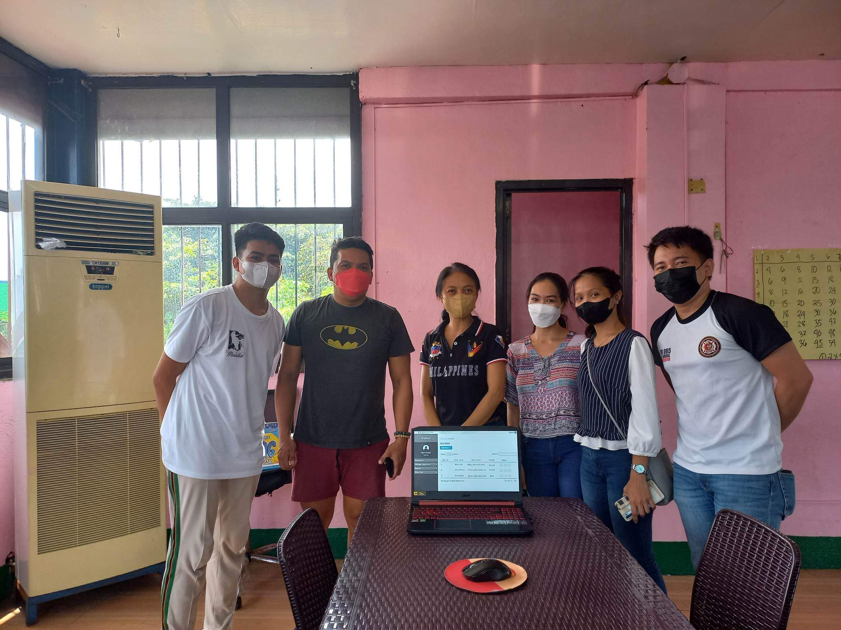

We had our first meeting with the barangay officials in Barangay 193 Zone 20 - Pasay City . The barangay officials have given their consent for the Barangay Monitoring and Management System with Data Analytics (BMMS) that we will develop.

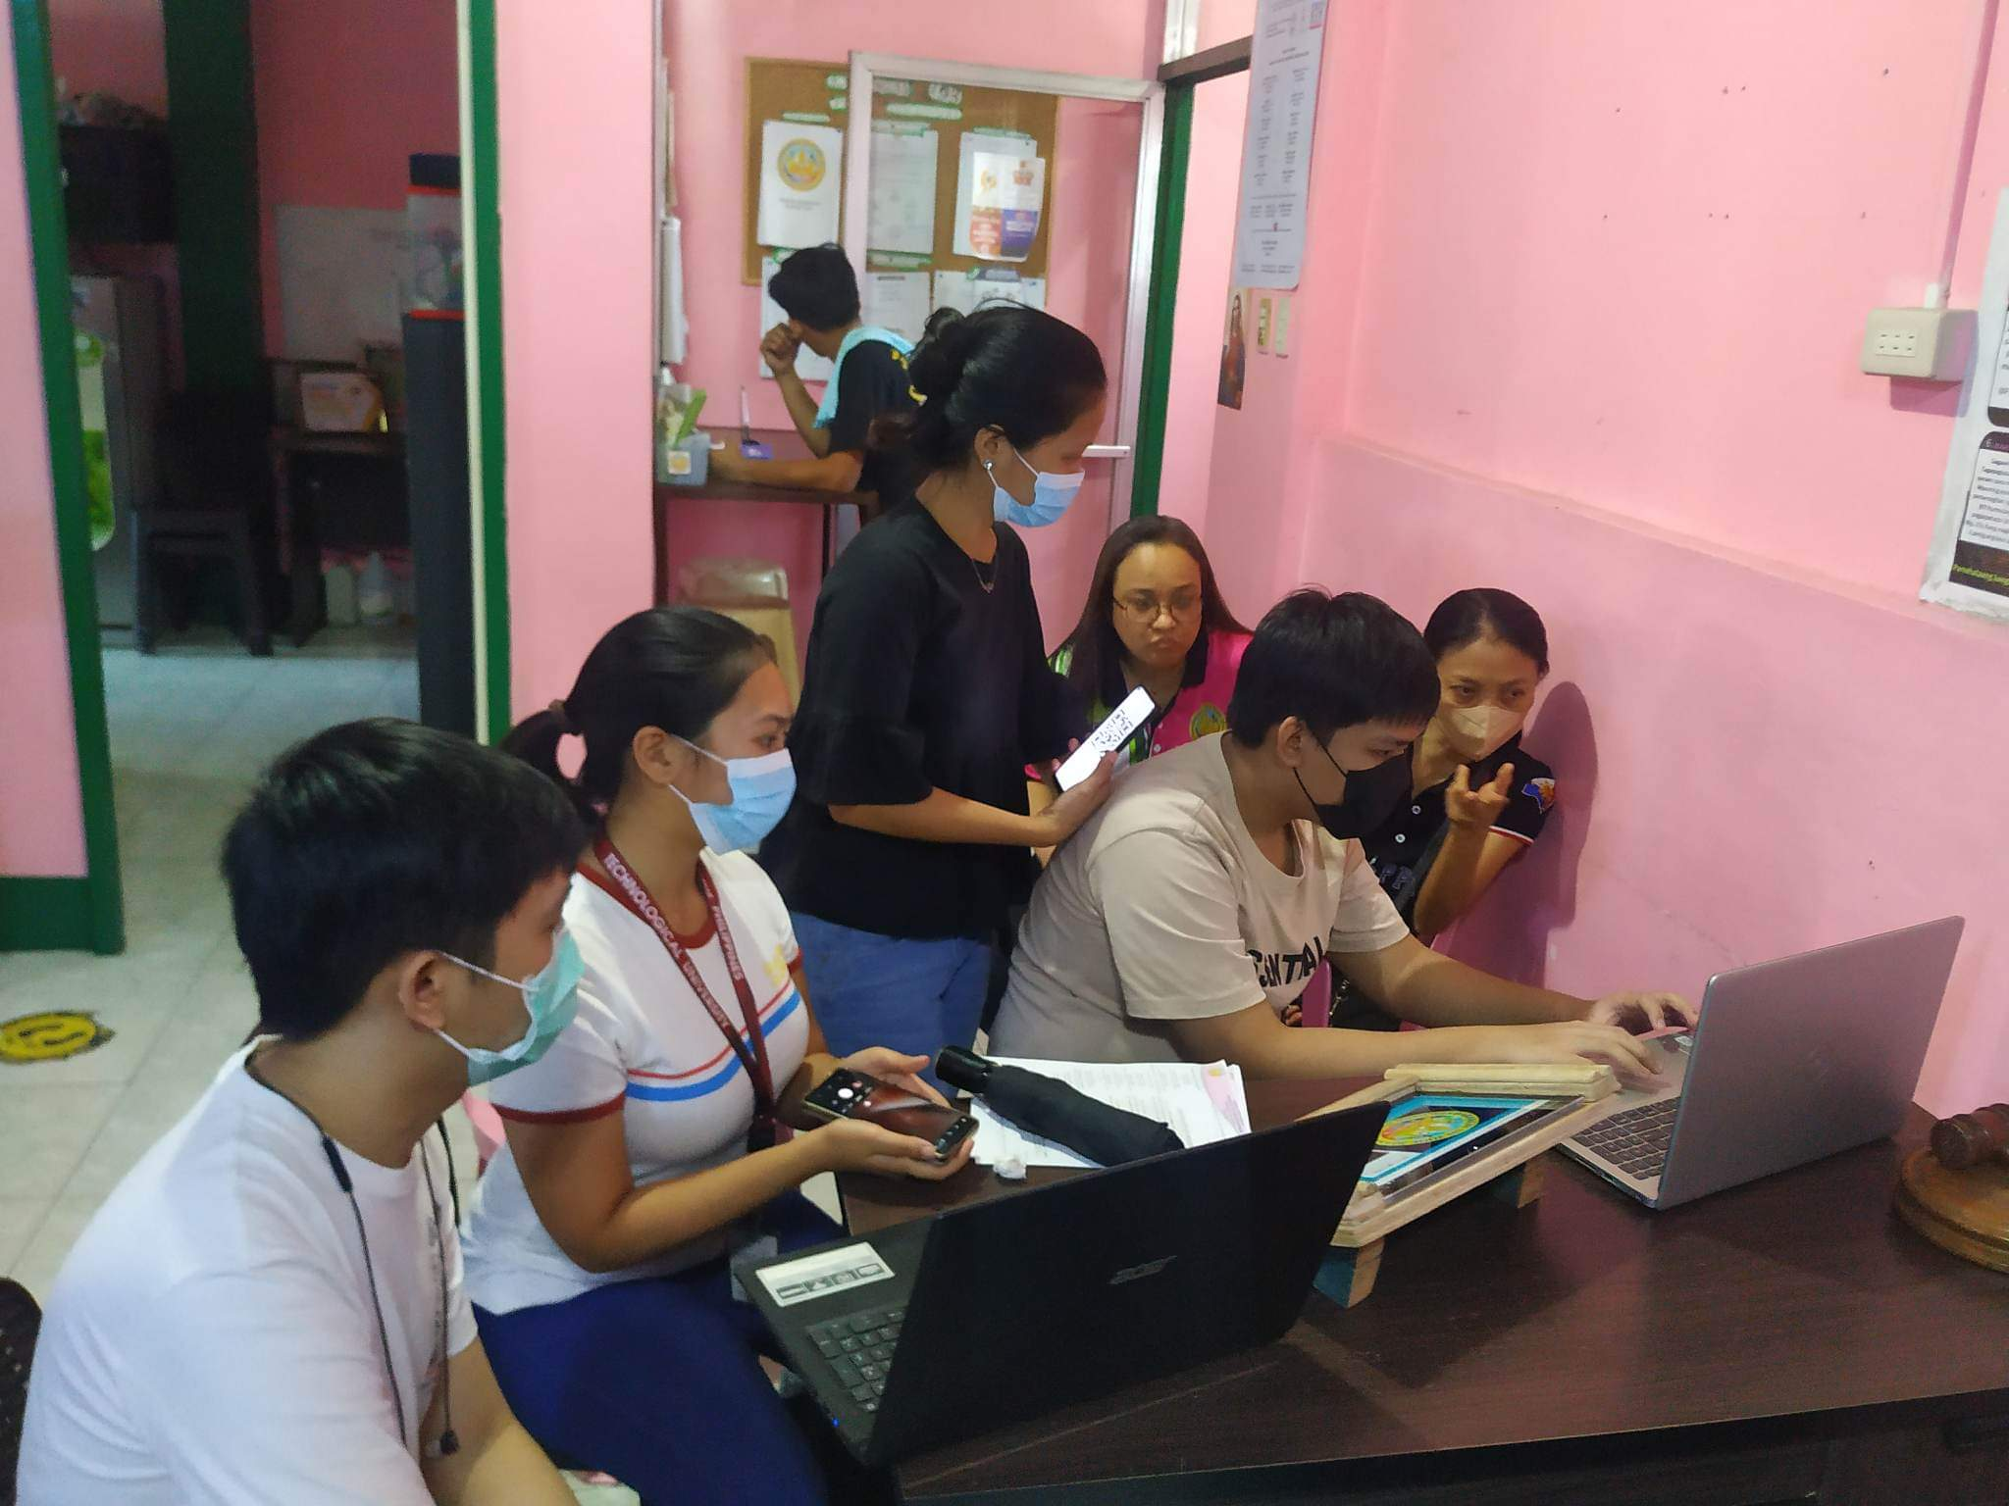

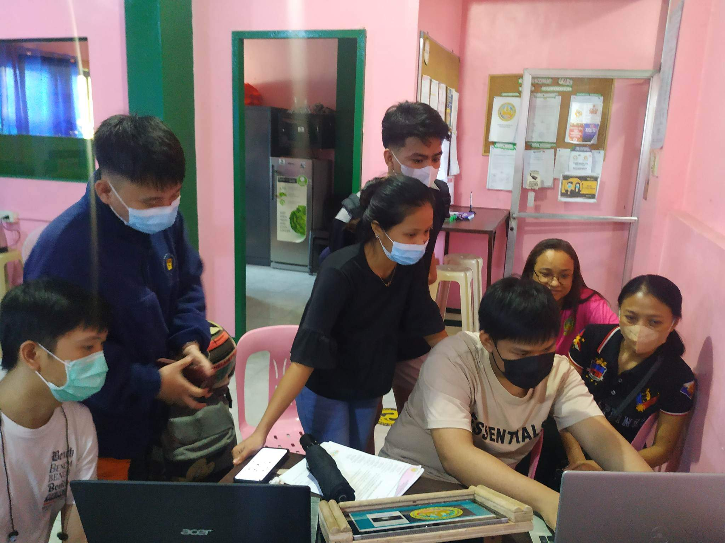

On this day, we test Barangay Monitoring and Management System with Data Analytics (BMMS) in Barangay 193 Zone 20 - Pasay City.

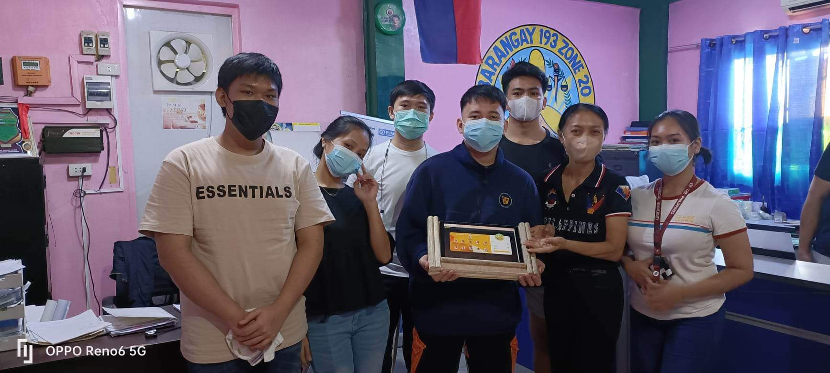

This is our final meeting with the officials of Barangay 193, Zone 20 Pasay City.

**APPENDIX J**

**USER’S MANUAL**

# RESEARCHERS’ PROFILE

**GENIKKA ROSE T. BAUTISTA**

226 Galicia St., Bangkulasi, Navotas City

09151905939

[bgenikkarose@gmail.com](mailto:bgenikkarose@gmail.com)

**EDUCATIONAL BACKGROUND**

**TERTIARY:**

* Technological University of the Philippines – Manila
* Bachelor of Engineering Technology major in Computer Engineering Technology
* 2018 – Present

**SECONDARY:**

* STI College Caloocan
* Information Computer Technology (ICT) major in Mobile App and Web Development
* 109 Samson Road Corner, Caimito St., Caloocan City
* 2016-2018
* Navotas National Elementary School
* M.Naval St., Sipac Almacen, Navotas City
* 2014-2016
* Mystical Rose School of Bulacan Inc.
* Magasawang Sapa Road, Caypombo, Santa Maria, Bulacan
* 2012-2014

**PRIMARY:**

* Mystical Rose School of Bulacan Inc.
* Magasawang Sapa Road, Caypombo, Santa Maria, Bulacan
* 2009-2012
* North Bay Boulevard North Elementary School
* Pescador II, NBBN, Navotas City
* 2008-2009
* Tangos Elementary School
* J. Pascual, Tangos, Navotas City
* 2007-2008

**CONFERENCES/SEMINARS/TRAININGS ATTENDED:**

* Needs Assessment and Technology Transfers
* Technological University of the Philippines – Manila
* April 6, 2022
* Technical Webinar on Security and Privacy
* DICT – Region 5 – Catanduanes
* October 20, 2022

__________________________

Signature

**CHRISTIAN JAMES D. PUNZAL**

2105 Raxabago Fernandez 2, Tondo, Manila

09669755343

[cjpunzal10@gmail.com](mailto:cjpunzal10@gmail.com)

**EDUCATIONAL BACKGROUND**

**TERTIARY:**

* Technological University of the Philippines – Manila
* Bachelor of Engineering Technology major in Computer Engineering Technology
* 2018 - Present

**SECONDARY:**

* AMA Computer Learning Center – Northbay Campus
* TVL – Information Computer Technology (ICT)
* JX9C+87C, Juan Luna St, Tondo, Manila, Metro Manila
* 2016-2018
* Florentino Torres High School
* 173-174 Tondo III, Juan Luna St, Tondo, Manila, Metro Manila
* 2011-2016

**PRIMARY:**

* Jose Rizal Elementary School
* 1012, 1860 Tayuman St, Tondo, Manila, 1012 Metro Manila
* 2006-2011

**CONFERENCES/SEMINARS/TRAININGS ATTENDED:**

* Programming Languages: Java, C, C++, C#
* Technological University of the Philippines – Manila
* October 21, 2022

__________________________

Signature



**BJORN P. VILLARTA**

Blk 12 Lot 9 Phase 5 Santa Barbara Villas 1

09075990366

[bjornvill20@gmail.com](mailto:bjornvill20@gmail.com)

**EDUCATIONAL BACKGROUND**

**TERTIARY:**

* Technological University of the Philippines – Manila
* Bachelor of Engineering Technology major in Computer Engineering Technology
* 2019 - Present

**SECONDARY:**

* Silangan National High School
* Acountancy, Business and Management
* Brgy. Silangan. 1850, Old Army Rd., San Mateo, Rizal
* 2017-2019
* Silangan National High School
* Brgy. Silangan. 1850, Old Army Rd., San Mateo, Rizal
* 2013-2016

**PRIMARY:**

* Silangan Elementary School
* AFP Housing, Langka St., Silangan, San Mateo, Rizal
* 2007-2013

**CONFERENCES/SEMINARS/TRAININGS ATTENDED:**

* Programming Languages: Java, C, C++, C#
* Technological University of the Philippines – Manila
* October 21, 2022

__________________________

Signature

**JOHN PAUL C. ANDAL**

P62-73 3rd 2nd St., Villamor Air Base, Pasay City

09684823850

[johnpaulandal080416@gmail.com](mailto:johnpaulandal080416@gmail.com)

**EDUCATIONAL BACKGROUND**

**TERTIARY:**

* Technological University of the Philippines – Manila
* Bachelor of Engineering Technology major in Computer Engineering Technology
* 2018 - Present

**SECONDARY:**

* Arellano University – Jose Abad Santos
* Information Computer Technology (ICT)
* Gil Puyat Avenue Corner, Taft Avenue, Pasay City
* 2016-2018
* Pasay City South High School
* Piccio Garden, Pasay City
* 2012-2016

**PRIMARY:**

* Villamor Air Base Elementary School
* Piccio Garden, Pasay City
* 2006-2012

**CONFERENCES/SEMINARS/TRAININGS ATTENDED:**

* Needs Assessment and Technology Transfers
* Technological University of the Philippines – Manila
* April 6, 2022

_________

__________________________

Signature

**ABEGAIL CATALAN**

110 – D Quirino St., Tondo, Manila

09952388601

[abbygailm12@gmail.com](mailto:abbygailm12@gmail.com)

**EDUCATIONAL BACKGROUND**

**TERTIARY:**

* Technological University of the Philippines – Manila
* Bachelor of Engineering Technology major in Computer Engineering Technology
* 2018 - Present

**SECONDARY:**

* Arellano University – Juan Sumulong Campus
* Information Computer Technology (ICT)
* Legarda, Manila
* 2016-2018
* Pasay City South High School
* Piccio Garden, Pasay City
* 2012-2016

**PRIMARY:**

* Villamor Air Base Elementary School
* Piccio Garden, Pasay City
* 2006-2012

**CONFERENCES/SEMINARS/TRAININGS ATTENDED:**

* Programming Languages: Java, C, C++, C#
* Technological University of the Philippines – Manila
* October 21, 2022

__________________________

Signature

**LIONEL M. HERNANDEZ**

156 Silangan Compound Zapote V, Bacoor, Cavite

09957616318

Lionelhernandez306@gmail.com

**EDUCATIONAL BACKGROUND**

**TERTIARY:**

* Technological University of the Philippines – Manila
* Bachelor of Engineering Technology major in Computer Engineering Technology
* 2018 - Present

**SECONDARY:**

* Bernardo College
* General Academic Strand (GAS)
* Pulang Lupa I, Las Piñas City
* 2016-2018
* Bernardo College
* General Academic Strand (GAS)
* 2012-2016

**PRIMARY:**

* Longos Elementary School
* Piccio Garden, Pasay City
* 2006-2012

**CONFERENCES/SEMINARS/TRAININGS ATTENDED:**

* Block Chain Technology
* January 5, 2023
* Cloud Computing
* December 9, 2022
* Technical Webinar on Security and Privacy
* October 20, 2022

__________________________

Signature